**Michigan EAB project – chapter draft**

Aaron Tayal

June 23, 2025

**Introduction**

Forests are increasingly impacted by anthropogenic stressors, including the establishment and spread of nonnative species (Lovett et al. 2006). Exotic tree-feeding insects have been especially significant, causing economic and ecological impacts (Gandhi and Herms 2010, Van Driesche and Reardon 2016). These pests can undergo exponential population growth because top-down and bottom-up processes are reduced in the invaded range. Insects introduced to a new region of the globe can escape their specialist natural enemies which might otherwise control their populations (Roy et al. 2011, Duan et al. 2023). Furthermore, native tree species do not share a coevolutionary history with nonnative insects and may lack the necessary physical or chemical defenses (Villari et al. 2016, Mech et al. 2019). Release from these top-down and bottom-up controls can lead to rapid and widespread mortality of host trees. Tree mortality causes ecological consequences which have short- and long-term impacts on forest structure and function. In the short term, tree mortality forms canopy gaps that increase light availability and temperature and alter soil moisture on the forest floor (Perry and Herms 2019). Depending on the size, surrounding canopy and understory trees or advanced regeneration will respond to the available resources and grow to fill the gaps. If the host tree species has surviving seedlings, saplings, or root sprouts, this regeneration may compete to reclaim the space. However, regeneration of the host tree species can be hindered by the continual presence of the nonnative insect. Eventually, host tree species may be functionally eliminated from forests, or they may persist (McCormick and Platt 1980). If they do persist, they may do so in a different size range, or only within certain forest types (Barnes 1976).

Emerald ash borer (EAB, *Agrilus planipennis* Fairmaire) is an introduced woodboring beetle (Coleoptera: Buprestidae) that has had substantial direct and indirect ecological impacts in forests (Klooster et al. 2018). First identified near Detroit, Michigan in 2002, EAB has since spread throughout the eastern United States and Canada. Extensive mortality of North American ash (*Fraxinus* spp.) has occurred in regions where EAB has become established, including widely distributed white ash (*Fraxinus americana* L.), green ash (*Fraxinus pennsylvanica* Marsh), and black ash (*Fraxinus nigra* Marsh) (Burns and Honkala 1990). For example, mixed deciduous forests near the epicenter of the EAB invasion experienced more than 99% mortality of canopy ash by 2009 (Klooster et al. 2013). Ash trees with EAB larvae tunneling in their vascular system exhibit symptoms like bark splitting, sprouting along the trunk, canopy foliage dieback, and death (Knight et al. 2014). Concurrent with the death of mature ash, viable seed production declined precipitously, which threatens to eliminate the ash from forests (Klooster et al. 2013). To attempt control of EAB populations, several biological control agents native to east Asia have been widely released in eastern North America. Three parasitoid wasp species have established and are impacting EAB populations (Duan et al. 2015, 2023, Aker et al. 2022, Quinn et al. 2023).

Although the majority of mature ash have died, ash seedlings and saplings that were too small to be colonized by EAB during the initial wave of mortality are abundant in many forest understories (Aubin et al. 2015, Ward et al. 2021). If this regeneration grows large enough to reproduce and generate viable seeds, then ash could remain a long-term component of eastern North American forests. However, EAB populations in post-outbreak forests remain at low densities. As ash saplings grow to larger sizes, they become susceptible, increasing the likelihood that persisting populations of EAB will kill them (Duan et al. 2017). Recent evidence suggests that the introduced parasitoids could provide enough EAB-population control to protect regenerating ash in post-outbreak forests (Duan et al. 2015, McCullough 2019). *Tetrastichus planipennisi* Yang (Hymenoptera: Eulophidae) parasitizes EAB larvae through the thinner bark of young ash trees (<12 cm in diameter) (Abell et al. 2012, Duan et al. 2023), while the longer ovipositor of *Spathius galinae* Belokobylskij (Hymenoptera: Braconidae) may allow it to parasitize EAB larvae within ash trees up to about 39 cm in diameter (Murphy et al. 2017). Meanwhile, the tiny *Oobius agrili* (Hymenoptera: Encyrtidae) parasitizes EAB eggs in bark crevices (Quinn et al. 2023). The long-term persistence of ash populations in natural forests of North America will depend on the dynamic interactions among the cohort of immature ash in the forest understory, competing plants, low-density EAB populations, and introduced parasitoids.

Although EAB attacks ash trees in a variety of forest types (Smith et al. 2015), the long-term persistence of ash may occur only in a subset of the forest types which it once occupied. Forests where ash is found include abandoned agricultural fields (Morris et al. 2023), mixed hardwood forests on slopes (Royo and Knight 2012), riparian areas along streams (Engelken et al. 2020), river floodplains (Siegert et al. 2021), swamps formed from glacial lake plains (Abella et al. 2019), and depressional areas fed by ground or surface water (Golet et al. 1993). These forests can be classified using a variety of abiotic characteristics, but hydrology is one of the most impactful because of its effect on tree survival and species composition (Megonigal et al. 1997, Niinemets and Valladares 2006). Forest stands may be classified as xeric upland, mesic riparian, or hydric swamp. Different ash species thrive in different hydrological niches (Wagner and Todd 2015). For example, black ash is often a dominant species in hydric forests and has adaptations to deal with seasonal flooding (Telander et al. 2015, Kolka et al. 2018). Furthermore, hydric, mesic, and xeric forests may differ in the size distribution of ash trees, the abiotic stressors present, and the understory vegetation types, which can all impact ash regeneration success (Smith 2006). In summary, ash regeneration may depend on the soil hydrology of the forest.

Given the uncertain future of ash in eastern North American forests, it is important to understand the potential for ash survival and regeneration in invaded forests with low-density EAB populations and a history of biological control releases. We resurveyed long-term forest research sites established during the early stages of ash mortality near the epicenter of invasion to investigate the occurrence and health of ash populations more than two decades after the detection of EAB. Our first objective was to quantify the abundance and health of ash regeneration in hydric, mesic, and xeric forests. We predicted that newly germinated seedlings would be absent due to a lack of seed-producing ash trees, and that the incidence of signs and symptoms of EAB would increase with increasing ash tree diameter (Klooster et al. 2013, Duan et al. 2017, Ward et al. 2021). Furthermore, we predicted that the occurrence of ash regeneration would depend on soil hydrology of the forest. Our second objective was to evaluate whether introduced parasitoid natural enemies of EAB could be recovered at our sites. Our third objective was, within hydric forests, to describe the tree species and ground vegetation types that might replace the space formerly occupied by ash.

**Methods:**

Study area

This study was conducted in 37 transects previously established in 2004-2008 in mixed hardwood stands on public land within the Upper Huron River Watershed in southeast Michigan (Table S1) (Smith 2006; Klooster et al. 2014; Smith et al. 2015). Forest transects were established in the Huron-Clinton Metroparks (Indian Springs, Kensington, and Hudson Mills) and Michigan State Recreation Areas (Pontiac, Highland, Proud Lake, and Island Lake) (Figure 1a). Transects were initially characterized by the dominant ash species present (*F. americana*, *F. pennsylvanica*, or *F. nigra*) and hydrologic conditions (xeric, mesic, or hydric soils). Transects in well-drained upland forests with white ash were classified as xeric (19 transects). Transects with moderately well-drained soils with mostly green ash were classified as mesic (8 transects). Transects in floodplains with water-saturated soils, standing water for part of the year, and black ash and/or green ash were classified as hydric (10 transects). Transects were located 24-45 km from the epicenter of EAB invasion in Canton, Michigan (Siegert et al. 2014), and have a long history of EAB. EAB was present in most transects in 2004-2005, and 99% of ash above 2.5 cm diameter were killed by 2009 (Klooster et al. 2013). Aside from hydrology, transects also varied in total tree basal area and density, tree species diversity, and ash basal area and density (Smith et al. 2015). Other than ash, common tree genera included maple (*Acer*), oak (*Quercus*), cherry (*Prunus*), hickory (*Carya*), tuliptree (*Liriodendron*), aspen and cottonwood (*Populus*), elm (*Ulmus*), basswood (*Tilia*), hophornbeam (*Ostrya*), and musclewood (*Carpinus*) (Smith et al. 2015). The region is a post-glaciated landscape, with moraines forming the upland areas. In some cases, precipitation seeps through the moraines and fills lowland areas with mineral rich water (Kost and O’Connor 2003).

Within each transect, three replicate 18 m radius circular plots (0.1 ha) were previously established with a multiscale sampling design to facilitate vegetation surveys (Fig. 1b). Each plot was composed of an 18 m radius main plot, one nested 8 m radius subplot, and four 4 m2 microplots, one in each cardinal direction. When established in 2004-2008, all plots contained at least two mature ash trees. Additional details on plot establishment and characterization are provided in Smith (2006). In the main plot, subplot, and microplots, we resurveyed ash trees, saplings, and seedlings, respectively, during the growing seasons in 2024 (30 transects) and 2025 (the remaining 7 transects).

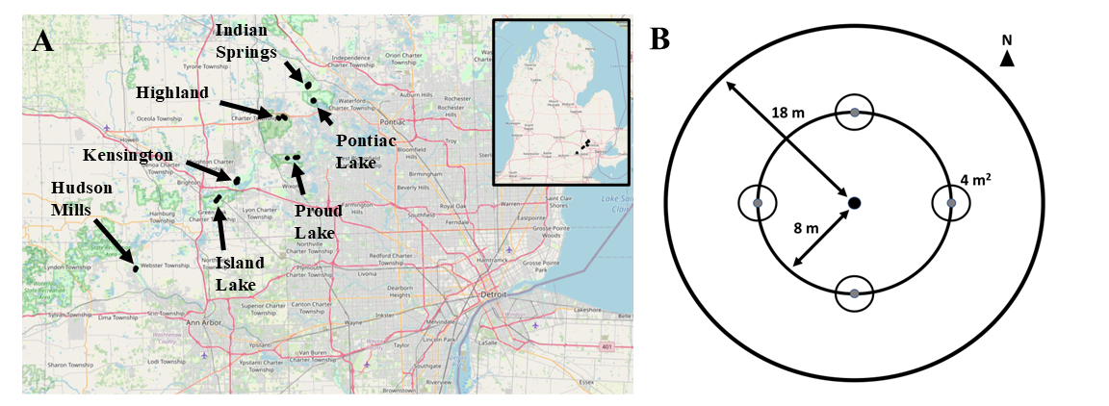

**Figure 1.** A) Map of southeast Michigan, showing the locations of the seven parks where forest stands were surveyed. B) Plot design, showing the 18 m radius main plot, the 8 m radius nested subplot, and the four 4 m2 area microplots located in cardinal directions.

Ash abundance and health

To assess the abundance and health of ash, canopy ash trees (≥10 cm diameter at breast height, DBH) were surveyed within the entire 18 m radius main plots, understory ash trees (2.5-10 cm DBH) and living ash saplings (≥137 cm in height but <2.5 cm DBH) were surveyed within the central 8 m radius subplots, and living ash seedlings (<137 cm in height) were surveyed within the 4 m2 microplots. All seedlings were checked for the presence of cotyledons which would indicate they were newly germinated (Klooster et al. 2013). Ash seedlings were counted in two height categories, <25 cm and >25 cm, and the percentage cover of ash seedlings in microplots was estimated (Klooster et al. 2013).

When present, canopy and understory ash (>2.5 cm DBH) were assessed individually for DBH, species, and health. All DBH measurements were taken at a height of 137 cm (Ward et al. 2021). Due to difficulties in distinguishing green and white ash, species designations were grouped into three categories: 1) black ash; 2) all other species of ash, including white ash, green ash, and potentially pumpkin ash (*Fraxinus profunda*); and 3) unknown ash species because the tree was dead. After recording ash species, the tree was checked for signs and symptoms of EAB, including the presence of D-shaped emergence holes, woodpecker predation marks, bark splitting, epicormic sprouts, and basal sprouts. Furthermore, the canopy condition was rated using a 1 to 5 scale, where 1 represented a healthy canopy, 5 represented complete defoliation of the canopy (possibly still with living epicormic sprouts), and 2-4 represented increasing stages of decline (Smith 2006, Klooster et al. 2013, Knight et al. 2014). For statistical analyses, we simplified the canopy condition variable into two binary variables, *ash tree decline* and *ash tree death*. *Ash tree decline* was coded as 1 if the canopy condition showed any signs of decline (i.e. if canopy condition ≥ 2) and 0 if the canopy condition = 1. *Ash tree death* was coded as 1 if canopy condition = 5, and 0 otherwise (adapted from Hoven et al. 2020).

EAB trapping

In 2024, we used purple-prism traps and multi-funnel traps to assess EAB presence at six of the seven study parks (all except Hudson Mills Metropark, Table S2). Two purple-prism traps were installed at each park, for a total of 12 prism traps. Additionally, three multi-funnel (Lindgren) traps were installed at one park, Pontiac Lake Recreation Area. Traps were hung on or near the biggest ash trees that could be found in preliminary site visits. Traps were installed between May 29 and June 5, 2024 (627-734 GDD, base 50 °F, single sine method), and removed between July 23 and July 25, 2024 (1733-1770 GDD) (“Online Phenology and Degree-day Models” 2022). Purple prism traps used standard purple (“Coroplast purple”) colored board coated with glue (TAD Insect Trap Coating, Great Lakes IPM). Traps were hung at varying heights and near ash of varying size classes, depending on what was found at a park (Table S2). All traps were baited with Manuka oil and a fresh lure was installed halfway through the summer, between June 25 and July 3 (1146-1283 GDD). All buprestid beetles were removed from purple prism traps monthly, and from multi-funnel traps weekly, and EAB were counted and sexed (Parsons 2008).

Parasitoid sampling

In 2024, yellow pan traps were used to determine whether the introduced biological control agents were present at one of the parks, Pontiac Lake Recreation Area. Plot 53 at Pontiac Lake (Transect: M, Hydrology: mesic) was chosen because initial visits showed large numbers of regenerating ash. A yellow pan trap was composed of two nested yellow plastic bowls attached to the trunk of a small ash tree and filled with a collection liquid (USDA–APHIS/ARS/FS 2021). The USDA design was modified by using polypropylene webbing straps instead of nails to attach to the tree (Figure S2). On June 4, 2024, 15 traps were attached at a height of 5-6 feet to small green or white ash trees with diameters between 3.2 and 9.6 cm DBH (Table S3). The collection liquid was 20% propylene glycol in water, with 1 drop of unscented dish soap. Traps were collected weekly until August 8, 2024, by pouring the collection liquid through a fine mesh paint filter (listed as 190 micron, actually ~300 micron = 0.3 mm), and rinsing with distilled water. Since the smallest introduced parasitoid, *Oobius agrili*, averages 0.95 mm long (Zhang et al. 2005), a 0.3 mm mesh size was sufficient to collect all three parasitoid species. Paint filters were cooled on ice within 30 minutes and frozen within 1 day (USDA–APHIS/ARS/FS 2021).

To sort trap contents, a paint filter was placed into a petri dish and 70% isopropanol in distilled water was added. The introduced biological control agents of EAB were identified using USDA guidelines (USDA–APHIS/ARS/FS 2021), before being confirmed by expert identification (Toby Petrice, personal communication). Specifically, the pan traps were searched for *Tetrastichus planipennisi* (Chalcidoidea: Eulophidae: Tetrastichinae), *Spathius galinae* and *S. agrili* (Ichneumonoidea: Braconidae: Doryctinae) and *Oobius agrili* (Chalcidoidea: Encyrtidae). Besides these species, the overall insect communities in pan traps were investigated. The orders Hymenoptera, Coleoptera, Diptera (except small larvae < 1 mm), Lepidoptera, and Hemiptera were counted. All Hymenoptera except Symphyta were sorted to superfamily level (Goulet and Huber 1993). Within the Ichneumonoidea, the families Ichneumonidae and Braconidae were distinguished. Within Chalcidoidea, the families Mymaridae and Encyrtidae were distinguished (Schauff and Grissel 1990).

Vegetation survey in hydric transects

In 2025, non-ash canopy trees (≥12.5 cm DBH) and understory trees (2.5-12.5 cm DBH) were counted in the 18 m radius main plot and the 8 m radius subplot, respectively, to investigate which species of trees are found in the hydric plots. The threshold between understory and canopy was set at 12.5 cm to be consistent with previous studies (Klooster et al. 2013, Smith et al. 2015). Only the 10 transects (30 plots) classified as hydric were surveyed. Trees were identified to species if possible and rated as living or dead (dead trees could still have living epicormic sprouts). Trees that divided into two or more branches below breast height (137 cm) were considered as the same tree and were counted if their sum of diameters was greater than the threshold (12.5 cm for the main plot or 2.5 cm for the subplot). Stems putatively connected below ground by root systems were considered as separate trees (Abella et al. 2019). Ash trees were counted at the same transects in 2024, so only non-ash trees were counted when transects were revisited in 2025. Although ash trees in the 10-12.5 cm DBH range were counted in the main plot in 2024, these ash trees did not meet the 12.5 cm threshold and were not included in the results for the tree survey. In addition to tree surveys, percentage cover was estimated for woody shrubs, graminoids (grasses, cattails, and sedges), skunk cabbage (*Symplocarpus foetidus*), ferns, and standing water. The percentage cover of the shrubs poison sumac (*Toxicodendron vernix*), spicebush (*Lindera benzoin*), winterberry (*Ilex verticillata*), and glossy buckthorn (*Frangula alnus*) were scored individually. Percentage cover was visually estimated for each of these categories by standing at 8 m in the NE, SE, SW, and NW quadrants of the 18 m radius plot. The four estimates for each cover type were averaged for a plot-level estimate.

Statistical analysis

Counts of ash canopy and understory trees, ash saplings, and ash seedlings were each summed across the three plots in a transect, which is the unit of replication. Density was calculated by dividing the count by the area over which they were counted. For canopy and understory trees, density of standing dead trees (canopy condition = 5) was calculated separately from density of living trees (canopy condition < 5). Basal area was calculated for living canopy and understory trees using the formula Σ(π*(d/2)2), where d is the DBH of each individual tree stem (Hoven et al. 2020). Multiple stems of a single tree were considered individually for basal area calculations but were considered as the same tree for tree counts.

The existing categorization of transects (n=37) by hydrological class (xeric: 19 transects, mesic: 8 transects, hydric: 10 transects, Table S1) was used to test whether the abundance of ash differs based on hydrology. The response variables were number of short ash seedlings (count), number of tall ash seedlings (count), mean percentage cover of ash seedlings (continuous), number of ash saplings (count), and number of living understory ash trees (count). Due to a low number of observations, the number of canopy ash (≥10 cm DBH) was not tested statistically. A separate model was created for each response variable. Hydrological class (xeric, mesic, or hydric) was treated as the fixed effect predictor and park where transect was located as random intercepts to account for unique site conditions at each of the seven parks. For each count response variable, a Poisson generalized linear mixed-effects model (GLMM) with a log link function was implemented using the package ‘lme4’ (Bates et al. 2015) in R (R Core Team 2024). The package ‘DHARMa’ was used to determine if the observed data was adequately modelled by the GLMM (Hartig 2024). Whenever the Poisson GLMM was determined to be overdispersed, a new model was created using the negative binomial error structure. This was implemented using the ‘lme4’ and ‘MASS’ (Venables et al. 2002) packages in R. The residuals of the negative binomial GLMM were similarly examined to verify model fit. Furthermore, the Akaike Information Criterion (AIC) was compared between the Poisson and negative binomial models to verify improvement in fit. The models for number of saplings and number of understory trees were singular fits, so the random effect of park for these response variables was dropped. For the mean percentage cover of ash seedlings, a linear mixed effects model with normally distributed residuals was used. The mean percentage cover was transformed using the function f(x)=ln(x+1) to satisfy the assumption of homogeneity of variances. For all response variables, the R package ‘car’ (Fox and Weisberg 2019) was used to test for overall differences between hydrological classes, and Tukey contrasts were calculated using the R package ‘emmeans’ (Lenth 2024).

To test the hypothesis that ash tree diameter would be positively correlated with signs and symptoms of EAB attack, generalized linear mixed-effects models with binomial error structure and logit link functions were implemented using the package ‘lme4’ (Bates et al. 2015). The binary (y/n) response variables tested were *woodpecker predation marks*, *bark splitting*, *epicormic sprouts*, *basal sprouts*, *ash tree decline*, and *ash tree death*. The fixed effect predictor variable was tree diameter at breast height (DBH). Plot was included as a random intercept to account for non-independence of trees in a plot. A Z-test was used to test the null hypothesis of no relationship between DBH and the EAB symptom. For our analysis, understory and overstory ash trees were pooled, and any tree was excluded if it belonged to a plot where less than 10 trees were found, which yielded a sample size of 283 trees (a cutoff of 5 trees in a plot was also tested and did not change the direction or significance of the results, Table S4). To assess the accuracy of the models, trees were binned into increments of 1 cm diameter, and the proportion of trees in each bin showing the EAB symptom was calculated. A model was judged as a good fit if the model trendline passed through the proportions for each bin.

To understand differences in forest community composition, the tree species composition of plots in 2024-2025 was investigated using nonmetric multidimensional scaling (NMDS). The Bray-Curtis dissimilarity between each of the 30 plots was calculated using the basal area (≥ 2.5 cm DBH) of each tree species, and the percentage cover of different ground-level vegetation types. Because basal area and percentage cover are on different scales, the plot × species matrix was standardized by dividing each cell by the maximum value in the column. Tree species were included in the analysis if they had ≥ 10 trees observed. The white oaks (*Quercus alba*, *Q. bicolor*, and *Q. macrocarpa*), red oaks (*Q. rubra* and *Q. palustris*), poplars (*Populus deltoides* and *P. grandidentata*), and elms (*Ulmus* sp.) were not identified to species level for the NMDS analysis.

**Results:**

In our survey of the 37 transects, we found 2981 ash seedlings, 1037 ash saplings, 276 living and 54 dead standing understory ash trees, and 7 living and 2 dead standing canopy (>10 cm DBH) ash trees. Ash seedlings were observed in 36 of the transects, but none had cotyledons (two individual ash seedlings with cotyledons were found outside of microplot survey areas). EAB adults were trapped at most parks, but in low densities (Figure S3).

Abundance of ash across size classes

The average density of ash seedlings ranged from 0 to 5.4 stems/m2 (0-54000 stems/ha), with an average of 1.65 stems/m2 (16500 stems/ha). Number of short ash seedlings (<25 cm height) averaged 0.88 stems/m2 and varied by hydrological class (χ2=12.6, 2 df, p=0.002). Hydric transects had lower numbers of short seedlings than mesic (Z=3.4, p=0.002) and xeric (Z=2.9, p=0.012) transects, while numbers of short seedlings were similar in mesic and xeric transects (Fig. 2A). Number of tall ash seedlings (25-137 cm height) averaged 0.78 stems/m2 and differed by hydrological class (χ2=19.1, p<0.001), with hydric transects having lower numbers than either mesic (Z=4.3, p<0.001) or xeric (Z=3.3, p=0.003) transects (Fig. 2A). About half of the seedlings in mesic and xeric forests were taller than 25 cm, while about half were shorter than 25 cm. Mean percentage cover of ash seedlings ranged from 0% to 38.1%, with an average of 10.7% across all transects. Similar to patterns for the density of ash seedlings, percentage cover of ash seedlings varied by hydrological class (χ2=17.7, p<0.001), with hydric transects having lower percentage cover of ash seedlings than mesic (t=3.8, p=0.002) and xeric transects (t=3.3, p=0.006).

The density of ash saplings ranged from 0 to 0.539 stems/m2 (0-5390 stems/ha), with an average of 0.046 stems/m2 (460 stems/ha). Numbers of ash saplings were similar among hydrological classes (χ2=0.26, p=0.88) (Fig. 2B).

A total of 330 understory ash trees (2.5-10 cm DBH) were found, and of these, 276 were living (canopy condition ≠ 5), while 54 were dead and standing. The density of living understory ash trees ranged from 0 to 1193.7 trees/ha, with a mean of 123.7 trees/ha. The number of living understory ash trees varied by hydrological class (χ2=14.6, p=0.001). Hydric transects had more understory ash trees than xeric transects (Z=3.7, p=0.001) and marginally more understory ash trees than mesic transects (Z=2.2, p=0.078) (Fig. 2C). Of the 330 understory ash trees, 131 were identified as being green, white, or pumpkin ash, while 178 were identified as black ash, and 21 were unidentified *Fraxinus* (Figure S1). Only 9 canopy ash trees (≥ 10 cm DBH) were found in all the plots, of which 7 trees were living. Living canopy ash trees within the plots ranged in diameter from 10.3 cm DBH to 12.4 cm DBH. The basal area of living ash trees (all ash ≥ 2.5 cm DBH and canopy condition ≠ 5) at the transect level ranged between 0 and 2.60 m2/ha, with an average of 0.24 m2/ha.

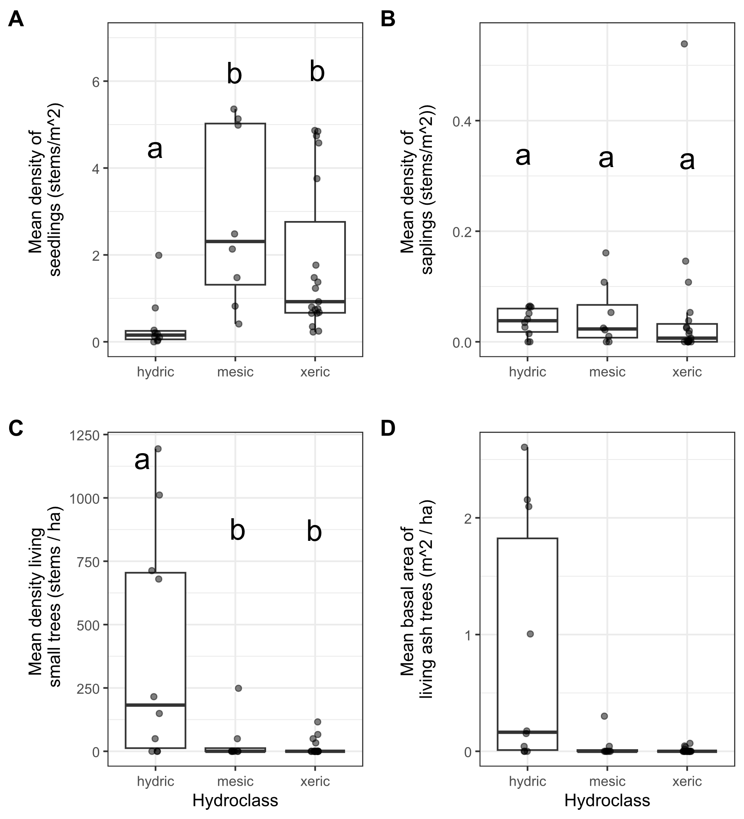

**Figure 2.** Ash occurrence in 37 transects in the Upper Huron River Watershed in southeast Michigan. The x-axis represents the soil hydroclass of the transect. Each data point represents a transect. Lowercase letters above bars indicate statistically significant differences at α=0.05. A) Mean density of ash seedlings (all ash with height < 1.37 m; short and tall seedling categories were combined for the graph), B) mean density of ash saplings (height ≥ 1.37 m and DBH < 2.5 cm), C) mean density of living understory ash trees (2.5 cm ≤ DBH < 10 cm), D) mean basal area of all living ash trees (DBH ≥ 2.5 cm). The basal area of living ash trees was not statistically investigated.

**Table 1.** Density (± standard error) of living ash (*Fraxinus*) regeneration in hydric (10 transects), mesic (8 transects), and xeric (19 transects) forests in the Upper Huron River Watershed in Southeast Michigan, USA. Only living trees are tabulated here. Data were collected in 2024 (97 plots) and 2025 (14 plots).

|  |  |  |
| --- | --- | --- |
| Size class | Hydrology class | Ash ha-1 |
| Short seedlings (<25 cm tall) | Hydric | 1,334 ± 952 |
|  | Mesic | 15,420 ± 4,920 |
|  | Xeric | 9,895 ± 2,458 |
| Tall seedlings (25-137 cm tall) | Hydric | 2,381 ± 994 |
|  | Mesic | 13,085 ± 2,563 |
|  | Xeric | 8,351 ± 1,625 |
| Saplings (>137 cm tall and <2.5 cm DBH) | Hydric | 360 ± 79 |
|  | Mesic | 472 ± 205 |
|  | Xeric | 517 ± 286 |
| Understory trees (2.5 – 10 cm DBH) | Hydric | 401 ± 145 |
|  | Mesic | 37 ± 31 |
|  | Xeric | 14 ± 7 |
| Canopy trees (>10 cm DBH) | Hydric | 2 ± 2 |
|  | Mesic | 0 |
|  | Xeric | 0 |

Signs and symptoms of EAB

Of the symptoms of EAB, bark splitting was the most common and was found on 193 (57%) ash trees (DBH ≥ 2.5 cm). Epicormic sprouts were found on 122 (36%) ash trees. Basal sprouts were found on 54 (16%) ash trees, while woodpecker predation marks were found on 46 (14%) ash trees. Out of a total of 338 trees, 229 (68%) had canopy condition=1 (meaning they were healthy), 33 (10%) had canopy condition=2, 13 (4%) had canopy condition=3, 7 (2%) had canopy condition=4, and 55 (16%) had canopy condition=5 (meaning they had a dead canopy). The D-shaped emergence holes from EAB were observed on a low percentage of ash trees, with only 8 trees (2%) recorded with visible exit holes.

The presence of woodpecker predation marks was positively correlated with tree diameter (DBH), with a 1 cm increase in DBH increasing the odds of woodpecker marks by a factor of 1.24 (Z=2.46, p=0.013) (Figure 3A). Similarly, presence of epicormic sprouts was positively correlated with DBH, with a 1 cm increase in DBH increasing the odds of epicormic sprouts by a factor of 1.31 (Z=3.49, p<0.001) (Figure 3C). The presence of canopy foliage decline was positively correlated with DBH, such that a 1 cm increase in DBH increased the odds of canopy decline by a factor of 1.22 (Z=2.89, p=0.004) (Figure 3F). No relationships were observed between DBH and bark splitting (Z=1.64, p=0.102), presence of basal sprouts (Z=1.16, p=0.245), and tree death (Z=0.21, p=0.831) (Figure 3, B, D, and E). The symptoms that showed the most inter-plot variation in prevalence were epicormic sprouts, basal sprouts, and bark splitting, while the prevalence canopy decline was more consistent between plots (Fig. S4).

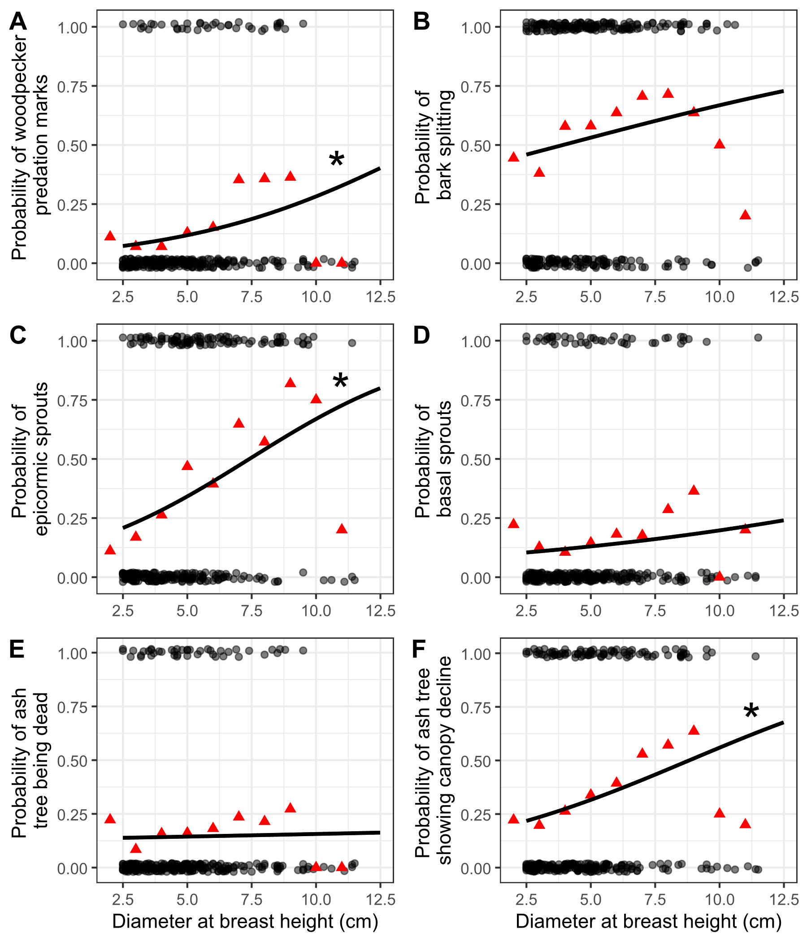

**Figure 3.** The presence or absence of symptoms of EAB plotted against tree diameter at breast height (DBH) for 283 trees in the 10 forest plots containing at least 10 trees. Grey circles are individual trees, which are plotted as y=1 for presence or y=0 for absence (points were vertically jittered slightly). Black line shows the overall fitted model, disregarding each specific random intercept for each plot. See Figure S4 for plots including each random intercept. Asterisk next to the lines for woodpecker predation marks, epicormic sprouts, and canopy decline indicate a slope significantly different from zero. Red triangles show the proportion of trees that have the symptom within a DBH bin. For E, tree death is defined as having a canopy condition of 5. For F, canopy decline is defined as having a canopy condition between 2-5 (minor to complete defoliation).

Parasitoid captures

Three introduced biological control agents were detected using pan traps, *Spathius galinae* (3 individuals collected), *Oobius agrili* (2 individuals), and *Tetrastichus planipennisi* (2 individuals). Yellow pan traps also caught a total of 1537 Hymenoptera, 1074 Diptera, 1163 Hemiptera, 77 Lepidoptera, 277 Coleoptera, and 152 other arthropods.

Vegetation in hydric stands

We found 18 genera of trees in the 10 hydric transects (Tables 2-5). The most common species in the canopy (≥ 12.5 cm DBH) were silver maple (*Acer saccharinum*, 303 living), Elm (*Ulmus* sp., 128 living), and Basswood (*Tilia americana*, 122 living) (Figure 4A). In all, we found 1030 canopy trees, of which 810 were living and 220 were dead standing trees. Meanwhile, the most common species in the understory (2.5 ≤ DBH < 12.5 cm) were musclewood (*Carpinus caroliniana*, 124 living), black ash (*Fraxinus nigra*, 122 living), and green ash (*Fraxinus pennsylvanica*, possibly with some *F. americana* and *F. profunda*, 112 living) (Figure 4B). In the understory, 792 trees were found, of which 638 were living and 154 were dead standing. The basal area of living trees in the canopy and understory averaged 21.1 m2/ha and 2.8 m2/ha, respectively (not counting understory shrubs). Of the ground-level cover types estimated in hydric plots, graminoids, skunk cabbage, and spicebush had the highest percentage cover values (Table 6). The invasive glossy buckthorn (*Frangula alnus*) had a mean percentage cover of 3.6%. The NMDS ordination of the 30 hydric plots resulted in a stress value of 0.187. Plots located within the same park generally clustered together in the ordination (Figure 5). The three plots within each transect usually clustered together, but some transects had inter-plot variation in tree and ground cover composition. This included transect DD at Island Lake and transect S at Indian Springs. The plots at Proud Lake were the most distinct from those of other parks.

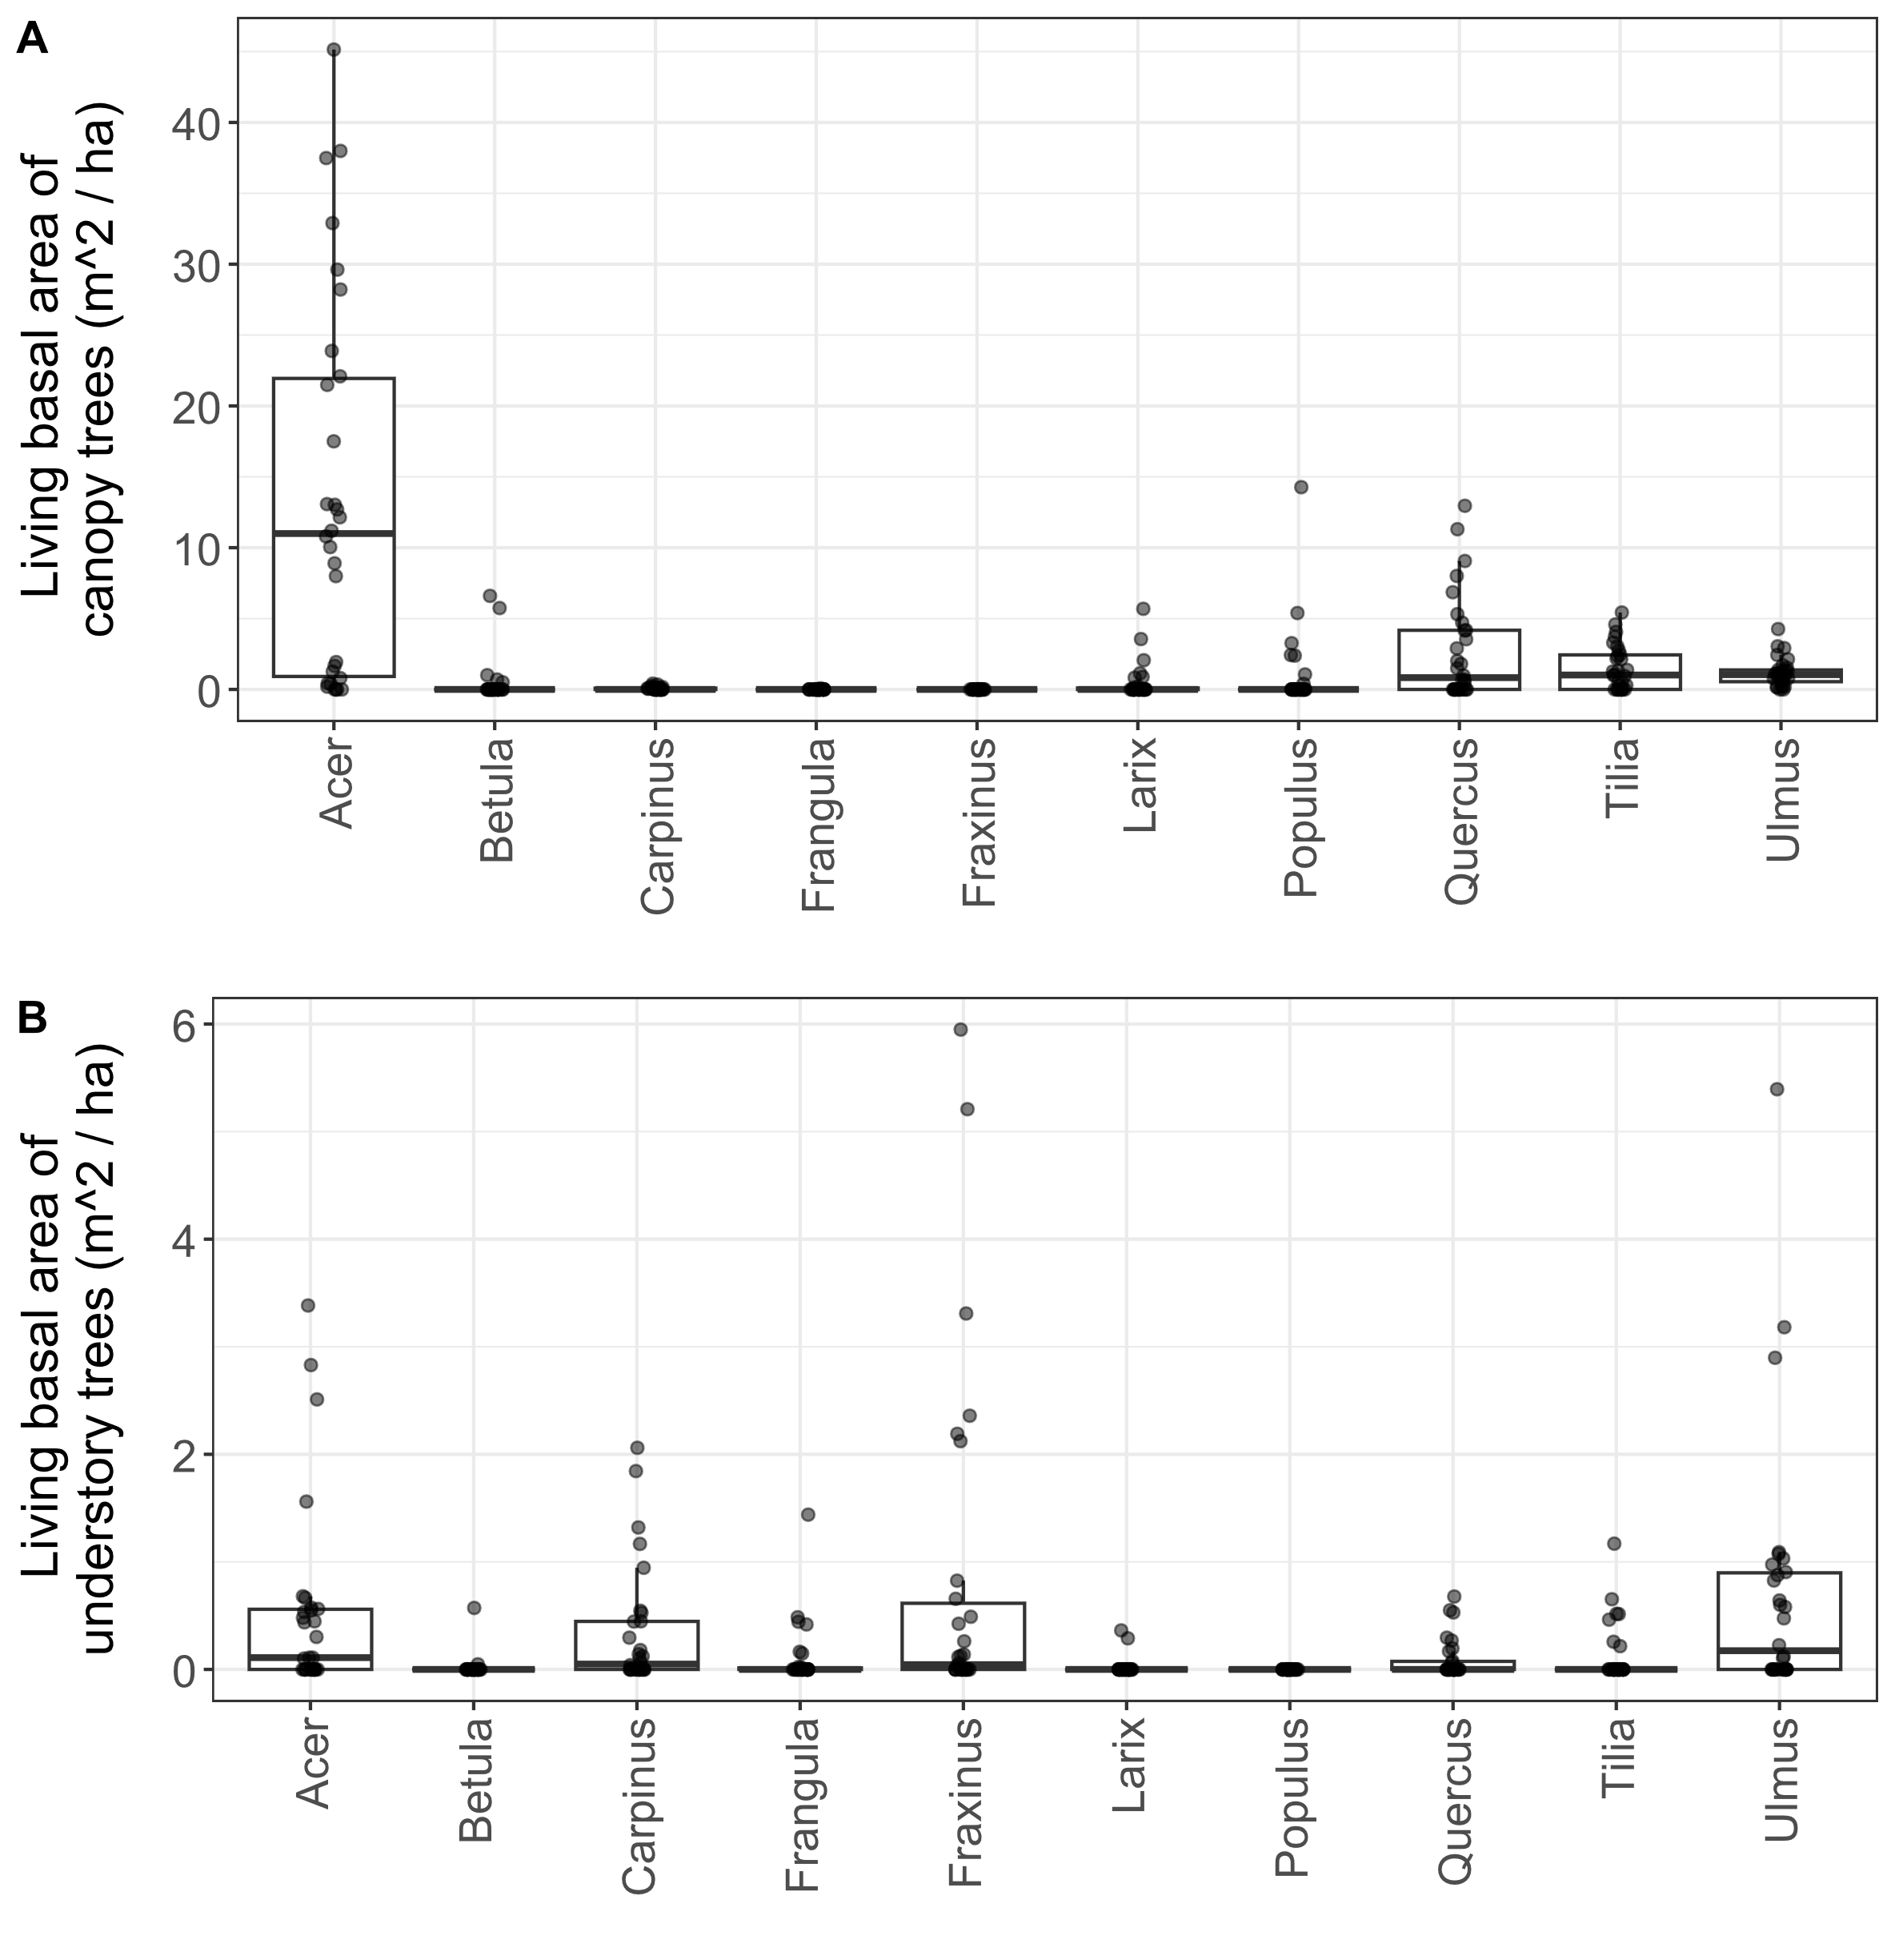

**Figure 4.** Basal area of living trees in 10 hydric transects (30 plots). Each dot represents a single plot. A) Canopy trees (≥ 12.5 cm DBH); B) understory trees (2.5-12.5 cm DBH). Tree genera were only included in the graph if their mean basal area was in the top seven for either canopy or understory trees. Note the difference in y-axis scale between the two graphs.

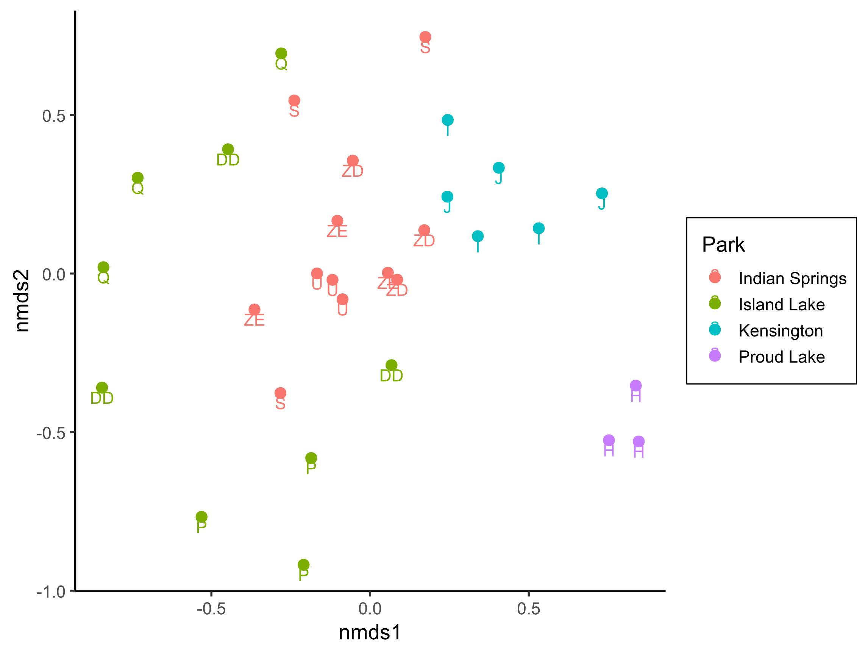

**Figure 5.** Nonmetric multidimensional scaling (NMDS) of the plant communities at the 30 hydric plots visited in 2025. Data used to generate the NMDS included both basal areas of tree species and percentage cover values for ground-level vegetation types. Points are colored based on the park and labelled by transect according to Table S1. The final stress value was 0.187.

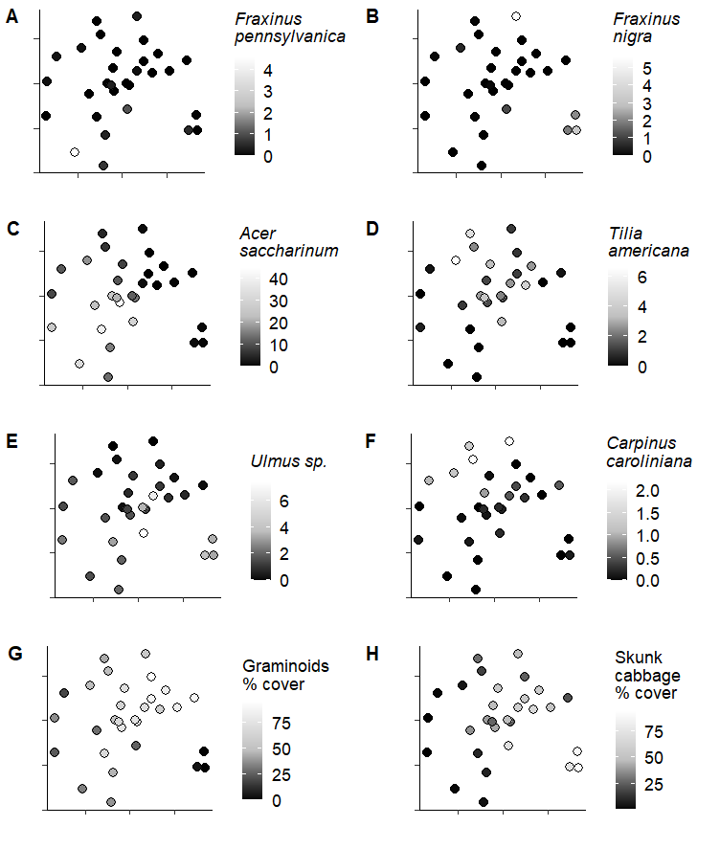 **Figure 6.** Basal area (A-F) or percentage cover (G-H) of variables plotted onto the nonmetric multidimensional scaling axes of Figure 5. The basal area values are for all stems ≥ 2.5 cm DBH and have units of m2 / ha. The percentage cover values range from 0-100%. Skunk cabbage is *Symplocarpus foetidus*.

**Table 2**. Relative density and relative dominance of tree genera found in the 4 hydric transects (12 plots) at Indian Springs Metropark in 2024-2025. Only living trees are counted. Canopy trees are ≥12.5 cm DBH, while understory trees are 2.5-12.5 cm DBH. A total of 294 living canopy trees were counted in the main plots and 172 living understory trees were counted in the subplots at Indian Springs. Zeros indicate a value less than 0.5% while dashes indicate absence. Shrub species were not counted.

|  |  |  |  |  |
| --- | --- | --- | --- | --- |
| **Indian Springs** | Relative density, % | | Relative dominance, % | |
| Genus | Canopy | Understory | Canopy | Understory |
| *Acer* | 50 | 12 | 79 | 17 |
| *Betula* | - | - | - | - |
| *Carpinus* | 6 | 27 | 1 | 17 |
| *Carya* | - | - | - | - |
| *Cornus* | - | - | - | - |
| *Fagus* | 1 | 1 | 2 | 2 |
| *Frangula* | - | 1 | - | 0 |
| *Fraxinus* | - | 33 | - | 22 |
| *Juniperus* | - | - | - | - |
| *Larix* | 0 | - | 0 | - |
| *Ostraya* | 1 | 2 | 0 | 1 |
| *Populus* | 1 | - | 1 | - |
| *Prunus* | - | 1 | - | 0 |
| *Quercus* | 7 | 3 | 7 | 3 |
| *Rhamnus* | - | - | - | - |
| *Tilia* | 18 | 1 | 8 | 2 |
| *Ulmus* | 16 | 21 | 4 | 36 |
| *Viburnum* | - | - | - | - |

**Table 3.** Relative density and relative dominance of tree genera found in the 3 hydric transects (9 plots) at Island Lake Recreation Area in 2024-2025. Only living trees are counted. Canopy trees are ≥12.5 cm DBH, while understory trees are 2.5-12.5 cm DBH. A total of 333 living canopy trees were counted in the main plots and 334 living understory trees were counted in the subplots at Island Lake. Zeros indicate a value less than 0.5% while dashes indicate absence. Shrub species were not counted.

|  |  |  |  |  |
| --- | --- | --- | --- | --- |
| **Island Lake** | Relative density, % | | Relative dominance, % | |
| Genus | Canopy | Understory | Canopy | Understory |
| Acer | 55 | 11 | 63 | 23 |
| Betula | - | - | - | - |
| Carpinus | 1 | 20 | 0 | 10 |
| Carya | 1 | 1 | 0 | 1 |
| Cornus | - | 0 | - | 0 |
| Fagus | 1 | 0 | 0 | 0 |
| Frangula | - | 10 | - | 6 |
| Fraxinus | - | 37 | - | 27 |
| Juniperus | - | - | - | - |
| Larix | - | - | - | - |
| Ostraya | - | 1 | - | 1 |
| Populus | 2 | - | 10 | - |
| Prunus | 1 | - | 1 | - |
| Quercus | 12 | 5 | 16 | 5 |
| Rhamnus | 0 | - | 0 | - |
| Tilia | 13 | 4 | 5 | 5 |
| Ulmus | 14 | 11 | 4 | 21 |
| Viburnum | - | - | - | - |

**Table 4.** Relative density and relative dominance of tree genera found in the 2 hydric transects (6 plots) at Kensington Metropark in 2024-2025. Only living trees are counted. Canopy trees are ≥12.5 cm DBH, while understory trees are 2.5-12.5 cm DBH. A total of 105 living canopy trees were counted in the main plots and 29 living understory trees were counted in the subplots at Kensington. Zeros indicate a value less than 0.5% while dashes indicate absence. Shrub species were not counted.

|  |  |  |  |  |
| --- | --- | --- | --- | --- |
| **Kensington** | Relative density, % | | Relative dominance, % | |
| Genus | Canopy | Understory | Canopy | Understory |
| Acer | 5 | 7 | 3 | 12 |
| Betula | 3 | - | 3 | - |
| Carpinus | - | 24 | - | 27 |
| Carya | 2 | - | 2 | - |
| Cornus | - | 3 | - | 1 |
| Fagus | - | - | - | - |
| Frangula | - | - | - | - |
| Fraxinus | - | - | - | - |
| Juniperus | 1 | - | 0 | - |
| Larix | 30 | 21 | 21 | 14 |
| Ostraya | 1 | - | 0 | - |
| Populus | - | - | - | - |
| Prunus | 1 | 3 | 0 | 4 |
| Quercus | 19 | - | 41 | - |
| Rhamnus | - | 3 | - | 1 |
| Tilia | 27 | 24 | 19 | 30 |
| Ulmus | 11 | 3 | 10 | 3 |
| Viburnum | 1 | 10 | 0 | 10 |

**Table 5.** Relative density and relative dominance of tree genera found in the 1 hydric transect (3 plots) at Proud Lake Recreation Area in 2024-2025. Only living trees are counted. Canopy trees are ≥12.5 cm DBH, while understory trees are 2.5-12.5 cm DBH. A total of 78 living canopy trees were counted in the main plots and 102 living understory trees were counted in the subplots at Proud Lake. Zeros indicate a value less than 0.5% while dashes indicate absence. Shrub species were not counted.

|  |  |  |  |  |
| --- | --- | --- | --- | --- |
| **Proud Lake** | Relative density, % | | Relative dominance, % | |
| Genus | Canopy | Understory | Canopy | Understory |
| Acer | 10 | 9 | 7 | 13 |
| Betula | 36 | 2 | 45 | 5 |
| Carpinus | - | 4 | - | 1 |
| Carya | - | - | - | - |
| Cornus | - | 1 | - | 0 |
| Fagus | - | - | - | - |
| Frangula | 1 | 14 | 0 | 6 |
| Fraxinus | - | 61 | - | 58 |
| Juniperus | - | - | - | - |
| Larix | 19 | - | 20 | - |
| Ostraya | - | - | - | - |
| Populus | - | - | - | - |
| Prunus | - | - | - | - |
| Quercus | - | - | - | - |
| Rhamnus | - | - | - | - |
| Tilia | - | - | - | - |
| Ulmus | 33 | 10 | 28 | 17 |
| Viburnum | - | - | - | - |

**Table 6.** Average percentage cover (± SE) of understory cover types in 10 hydric transects (30 plots). Standard errors were calculated using n=30.

|  |  |  |  |  |
| --- | --- | --- | --- | --- |
| Cover type | Scientific name | Mean percent cover (%) ± SE | | |
| Water |  | 9.8 | ± | 2.6 |
| Graminoids | Poales | 52.7 | ± | 5.0 |
| Skunk cabbage | *Symplocarpus foetidus* | 37.6 | ± | 5.0 |
| Ferns |  | 16.5 | ± | 2.9 |
| Spicebush | *Lindera benzoin* | 19.2 | ± | 4.4 |
| Winterberry | *Ilex verticillata* | 5.7 | ± | 1.9 |
| Glossy buckthorn | *Frangula alnus* | 3.6 | ± | 1.2 |
| Poison sumac | *Toxicodendron vernix* | 2.1 | ± | 0.9 |
| Other woody shrubs | *Elaeagnus umbellata, Cornus* sp.*, Rosa* sp.*, Vaccinium* sp.*, Corylus* sp., etc. | 5.0 | ± | 0.8 |

**Discussion**

Fifteen years after the mortality of 99% of ash trees in forest stands in southeast Michigan, we surveyed for the occurrence and health of ash regeneration in hydric, mesic and xeric forests, the presence of introduced natural enemies, and the vegetation communities in hydric forests.

We found that the amount of surviving ash regeneration strongly depended on soil hydrology, but patterns varied for seedlings vs. small trees. Ash seedlings (<1.37 m tall) were abundant in the understories of mesic and some xeric forests but were scarce in hydric forests. In contrast, living small ash trees (2.5-10 cm DBH) were often abundant in hydric forests, but were scarce in mesic and xeric forests. Thus, soil hydrology, or something that varies with it, exerts a strong influence on ash regeneration in our study stands.

Ash seedlings were particularly abundant in mesic forests, often covering a sizeable percentage of the forest floor (16.6% in mesic forests), and were sometimes abundant in xeric forests. The densities of ash seedlings in hydric, mesic, and xeric forests averaged ~4,000, ~30,000, and 18,000 seedlings ha-1, which are less than half of what they were in 2010 (Klooster et al. 2013), but still are a prominent component of the understory in mesic and xeric forests. The persistence of ash seedlings is impressive given that almost all of the seedlings we observed in 2024-2025 must have germinated before 2010, because 2010 is when the germination of new ash seeds almost entirely ceased at our study transects (Klooster et al. 2013).

Multiple studies of ash regeneration have found different processes which affect the density of ash seedlings on the forest floor. First, the density of surviving seed-producing ash trees affects seedling densities (Kashian 2016, Morris et al. 2023). When some trees survive EAB attack, or when the basal sprouts of top-killed trees survive, they can continue to produce ash seeds, which replenishes ash seedlings in the understory (Kashian 2016). However, in our transects, 99.7% of ash ≥ 2.5 cm DBH had died by 2009, meaning there were not any sources of new ash seedlings. A second process that affects ash seedling densities is competition with understory plants. In a study of canopy gaps created by EAB along first-order streams, higher densities of ash seedlings were found in the surrounding forests compared to canopy gaps, even though the canopy gaps were previously dominated by green and black ash trees (Engelken et al. 2020). The authors hypothesize that competition with dense understory vegetation, such as sedges (*Carex* sp.) may limit ash seedling establishment. In our study, we also found high densities of graminoids in hydric transects (mean 52.7% cover), which may explain why ash seedling densities were lower in hydric transects than mesic or xeric. Finally, variability in water levels can hinder seedling establishment and survival. In swamp forest of northwestern Ohio, seedling composition changed from year to year, which was attributed to flooding that killed seedlings (Abella et al. 2024). Just as flooding can kill seedlings, drought can do the same: green ash seedlings exposed to drought conditions reduced their leaf area (Shumway et al. 1991), which would decrease their ability to persist on the forest floor. This could explain why mesic forests, on average, had the highest densities of ash seedlings.

Unlike ash seedlings, the density of small ash trees (2.5-10 cm DBH) tended to be higher in hydric transects than mesic or xeric. The densities of small ash trees in hydric transects increased from a mean of 11.8 living stems ha-1 in 2009 (during peak EAB outbreak) to a mean of 401 living stems ha-1 in 2024-2025, indicating recruitment from saplings. Thus, following the near-complete elimination small ash trees during the peak of EAB populations, recovery has begun to occur in hydric forests. This result contrasts with that of a study using Forest Inventory and Analysis (FIA) data to assess ash regeneration (Ward et al. 2021). The FIA study found that within the Lower Peninsula of Michigan and in northwest Ohio, where EAB has been present the longest, densities of living ash between 2.54-12.7 cm had decreased from one survey to the next (from the 2002-2007 survey to the 2013-2018 survey). Our survey shows that ash within this size range can increase in abundance in post-outbreak forests. Although the recruitment we observed is promising, the living basal area of all ash ≥ 2.5 cm DBH has not recovered to what it was before EAB invasion. Our hydric transects averaged 0.82 m2 ha-1 of ash living basal area in 2024-2025, compared with 7.5 m2 ha-1 before the EAB invasion (Klooster et al. 2013). This is because living ash trees ≥ 10 cm DBH are currently rare and the maximum diameter ash we found within the transects was 12.4 cm DBH, whereas these forests used to contain ash canopy trees.

The higher abundance of ash small trees in hydric transects could be explained by multiple processes. For one, the pre-EAB basal area and especially stem density of ash was greatest in hydric transects (Klooster et al. 2013). Following ash mortality, ash regeneration from seedlings and root sprouts would benefit from large canopy gaps in hydric stands and would respond with increased growth rate. Although the individual ash canopy trees were smaller in pre-EAB hydric forests compared to white ash in pre-EAB xeric forests (Smith 2006), they were more numerous in hydric forests, which would have created multi-tree gaps. Another contributing factor is the high tolerance of ash to floodwater. When the water table rises to near or above the ground, hypoxic or anoxic conditions develop around tree roots, which may cause damage. However, black ash and green ash have adaptations like hypertrophied lenticels and adventitious root formation which help rid toxic metabolites and facilitate gas exchange during floods (Tang and Kozlowski 1984, Kreuzwieser and Rennenberg 2014). In fact, black ash had the highest transpiration at very wet field sites in Minnesota, indicating that it continues to function when other species would have their stomata closed (Kreuzwieser and Rennenberg 2014, Telander et al. 2015). This is reflected in black ash’s published waterlogging tolerance rating, which is the highest of all tree species we found in hydric transects (Niinemets and Valladares 2006) (Table S5). We hypothesize that periodic flooding events could have stressed or killed non-ash sapling competitors such as hornbeam (*Carpinus caroliniana*), allowing ash saplings to persist and grow into small ash trees. Moreover, the death of canopy ash trees may have increased the water table height due to a reduction in transpiration (Slesak et al. 2014), which may have further favored ash saplings due to their flood tolerance. Ash saplings (<2.5 cm DBH) and small trees (2.5-10 cm DBH) can grow rapidly, increasing their basal area by 0.25 and 0.15 m2 m-2 yr-1, respectively (Morris et al. 2023), which could explain why we observed high recruitment into the small tree size class in hydric forests.

For ash to remain a long-term component of the forest, enough ash trees need to grow big enough to produce seeds for the next generation of trees. However, we found high rates of EAB symptoms on small ash trees, such as bark splitting (57%) and epicormic sprouting from the trunk (36%). Thus, EAB is still a main factor affecting the health of small ash trees. Some indicators of ash health varied over the range of tree diameters surveyed, whereas others did not. For example, trees closer to 10 cm in diameter were more likely to have epicormic sprouts, woodpecker predation marks, and foliage decline, than smaller individuals. However, a high rate of bark splitting and was found across a range of ash diameters, even including smaller saplings. And the proportion of standing ash trees that were dead did not vary significantly by tree diameter across the 2.5-10 cm range. These findings reflect the complexity of the interactions between EAB, ash trees, parasitoids, and avian predators. For example, EAB females may oviposit on ash saplings as small as 2 cm in diameter (Aubin et al. 2015), which results in the formation of bark splits. However, ash trees bigger than 4 cm in diameter may be more suitable for larval development due to their thicker bark (Timms et al. 2006). Meanwhile, these larvae and prepupae within larger ash trees may be more desirable for woodpecker predator foraging during winter (Wilson et al. 2024). Larger ash trees may also display a more prolonged period of decline following EAB attack, compared to smaller trees which have accumulated fewer resources.

Despite the high prevalence of EAB symptoms, we found some trees without any signs or symptoms of EAB. We found ash regeneration as large as 11 cm DBH without any EAB symptoms. At our study plots, we observed a mix of healthy and declining trees (Fig. 3F, Fig. S4F), indicating that dispersal limitation of EAB is not protecting ash trees. The ability of these trees to maintain their health in the presence of EAB could be the result of parasitism, antixenosis, and/or antibiosis. Introduced and native parasitoid wasps can suppress populations of EAB, which could reduce the number of ovipositing females and thus reduce larval densities within ash trees (Duan et al. 2023). If parasitoids can find low-density EAB larvae within otherwise healthy ash trees, then they could help prevent the tree’s condition from worsening. In one study, parasitism rates were slightly lower in EAB larvae dissected from healthy ash trees, compared to declining ash trees (Wilson et al. 2024). This suggests that parasitoids alone may not be able to protect ash regeneration, but more research is needed to understand the host-seeking behavior of parasitoids (Johnson et al. 2014). Antixenosis, or the ability of a plant to discourage an herbivore from choosing it, could be performed by ash trees via altered leaf chemistry and/or volatile emissions (Cipollini and Peterson 2018). Adult EAB feed on ash leaves, and differences in feeding preference on different ash genotypes could correspond to differences in relative oviposition preference (Koch et al. 2015). Antibiosis, on the other hand, is the ability of a plant to harm or kill an herbivore that feeds on it. Ash trees can produce phenol compounds that can become oxidized and generate reactive oxygen species in the gut of the EAB larvae (Villari et al. 2016). Ash tree genotypes vary in their defense compounds, and some genotypes result in EAB larvae with reduced weight or complete failure to develop (Koch et al. 2015). Thus, there are multiple ways that ash regeneration could survive to become mature trees.

We recovered three species of introduced natural enemies of EAB in our yellow pan trap sampling, including *Tetrastichus planipennisi*, *Spathius galinae*, and *Oobius agrili*. We sampled at a park (Pontiac Lake) where, to our knowledge, no releases have been made of parasitoids. Instead, parasitoids have been released at parks in the surrounding area, including *S. galinae* (2021) and *O. agrili* (2012) at Seven Lakes State Park (~13 miles away) and *T. planipennisi* (2009, 2010, 2011) at Island Lake and Kensington (~15 miles). While *T. planipennisi* and *S. galinae* are capable of rapid dispersal to parasitize EAB larvae in new locations, *O. agrili* may disperse more slowly (Quinn et al. 2022b, Aker et al. 2022, Quinn et al. 2023). However, even though it is only around 0.95 mm in length, *O. agrili* was found to travel 45 m in 48 hours, indicating it may be more capable of dispersal than initially thought (Quinn et al. 2022a). Our results highlight the difficulty in using yellow pan traps to assess populations of introduced EAB parasitoids. Out of the 1537 Hymenoptera individuals we caught, only 7 (0.46%) were parasitoids of EAB introduced from its native range. Another study compared three methods of detecting EAB parasitoids (bark peeling, sentinel logs, and yellow pan traps) and found that the pan traps were the least time efficient, requiring 18.7 h of labor per detection for *T. planipennisi* and 31.1 h per detection for *S. galinae* (Rutledge et al. 2021). Nevertheless, pan traps are still useful as a method to detect *O. agrili* egg parasitoids, as well as native North American larval parasitoids (Petrice et al. 2021, 2025).

Within the 10 hydric transects surveyed, we found substantial variability in tree species composition. At Proud Lake (PLWET), we found forests dominated by yellow birch, American elm, tamarack, and strong regeneration of younger black ash trees. At Kensington (KENWET, KENWET3), we found open canopies with scattered basswood, tamarack, and oaks. At Island Lake (ILLOW, ILRIP, ILCC) and Indian Springs (ISLD, ISRIP, ISBR, and ISBRS), silver maple dominated in many of the plots. These differences in species composition likely result from differences in soils and site history. For example, hydric sites may be fed by surface water or by ground water, and those fed by groundwater often have higher pH, higher concentrations of Ca2+ and Mg2+ ions, and different seasonal patterns of water table height (Golet et al. 1993). Tree species such as basswood (*Tilia americana*) may be more successful in higher pH soils, or in soils with higher amounts of nitrogen (Burns and Honkala 1990). The hydric transects at Kensington and Proud Lake have species such as tamarack and poison sumac, and Proud Lake also has yellow birch, which indicates these areas may be relict conifer swamp (Barnes 1976, Kost and O’Connor 2003). In the past, these forests may have been dominated by northern white cedar (*Thuja occidentalis*), which is now restricted to higher latitudes (Kost and O’Connor 2003). Ash tree regeneration is occurring in some hydric forests, but not all.

Other ideas:

In Asia, where EAB is native, it seeks out ash trees that are already stressed. That is why girdling ash trees allows for the detection of low density EAB populations: because the girdled tree acts as a trap by emitting volatile attractants (Tluczek et al. 2011). We propose that the future of the EAB in North America could be similar: low density populations of EAB would continue to attack and kill stressed ash trees, while some ash trees remain healthy.

We also observed some ash regeneration resulting from top-killed trees which subsequently grew basal sprouts that became small trees.

Around 7 years after peak EAB densities, another study in Michigan similarly found that almost all ash trees >13 cm DBH had been killed, which significantly reduced the carrying capacity for EAB. The two sites had low densities of surviving small ash trees, but one site (Ocqueoc) had high densities of ash saplings (1,530 saplings/ha) (Siegert et al. 2021). Thus, substantial variability exists between sites in the abundance and size of ash regeneration.

In a study of Forest Inventory and Analysis (FIA) data, (Ward et al. 2021). The story from our transects is similar but not identical. We found hardly any ash trees above 10 cm DBH in our plots, but we did find higher densities of ash in the 2.5-10 cm DBH range in hydric transects and evidence that these densities have increased since 2009. Thus, the FIA survey in 2013-2018 told the story of what happens to ash trees during peak EAB densities. Our data shows that numbers of ash in the 2.5 cm – 10 cm DBH range can begin to increase in post-outbreak forests, possibly due to reduced EAB densities.

We also found sizeable numbers of ichneumon wasps, platygastroid wasps, fairy wasps, and many others. What are the hosts of these parasitoids? Does the distribution of different parasitoid superfamilies, along with the different orders of insects captured in the pan traps, indicate anything about the other biological processes occurring there? Do any of the parasitoids show seasonality?

-A result about what genera of trees, if any, have increased in basal area in hydric transects. And whether these genera are adapted to flooding stress, and whether they have any other threats.

-A note about the ground cover of hydric sites, and what kinds of wildlife can be supported by shrub wetlands, sedge meadows, and spicebush-dominated areas.

-I think it’s important to note other potential factors that might be controlling the response of hydric forests to EAB. For one, the pH of the ground. Some hydric forests might have higher pH, hard water from groundwater flow. Other forests might have lower pH water from rainfall. White ash prefers soils with higher levels of Ca2+ and Mg2+ ions (Royo and Knight 2012), and it is conceivable that the other species of ash could also be affected by pH. Additionally, the forests on river floodplains might differ from those in swampy areas farther from rivers, because flowing water can have higher dissolved oxygen than standing water, and rivers can be a source of nutrients. The soil type could also influence forest response to EAB. Some swamp forests have mineral soils only a few feet below a muck layer, while other forests have organic peat soils.

-Small green and black ash trees are abundant in some hydric forests, but not all.

-Compare to Siegert, Engelken, Abella, etc.

-Occurrence of epicormic sprouts, woodpecker predation marks, and defoliation all increase with increasing tree diameter from 2.5 cm to 10 cm. In the 8 – 10 cm DBH range, more than half of ash trees were showing epicormic sprouts, and more than half showed signs of canopy decline. However, a few trees above 10 cm DBH were found to be healthy and free from EAB signs and symptoms. The incidence of bark splits is almost 50% even at 2.5 cm DBH, indicating that EAB is attacking these small trees. The incidence of standing dead ash trees did not exhibit a significant relationship with DBH, indicating that ash tree mortality is occurring across a range of DBHs.

-Figure out what signals a tree to produce epicormic sprouts. Figure out how epicormic sprouts relate to captures of parasitoids.

-What stage of EAB do woodpeckers eat, and how much population control do they create?

-The fact that some trees are healthy even above 10 cm DBH means that they may be resistant to EAB. Look into the different mechanisms of resistance (antibiosis, antixenosis).

-Look into what factors control the EAB female to find a new host tree, and what allows the larvae to successfully complete their development.

-Look into the health findings of other studies on ash trees.

A paragraph about compensatory growth:

Because ash previously composed a large portion of total tree biomass in multiple forest types (Wagner and Todd 2015), the death of most overstory ash trees led to a reduction in living tree biomass. It is uncertain which trees, shrubs, or herbaceous plants will replace the space previously occupied by ash trees. In one scenario, the surrounding non-ash canopy trees increase their growth rate after the death of canopy ash, in a process called compensatory growth. Compensatory growth was observed in forests of Ohio between 2012 and 2014, where plots with higher amounts of declining ash trees had higher growth rates of non-ash trees (Hoven et al. 2020). A similar pattern was found using tree cores of red and silver maples (*Acer rubrum* and *Acer saccharinum*) in northeast Ohio (Costilow et al. 2017). However, another study which simulated EAB invasion in swamp forests of Upper Michigan found that the growth rates of non-ash overstory trees did not respond to the girdling or cutting of ash trees, at least for the first three growing seasons. Rather, herbaceous plants, including sedges (*Carex* sp.) and obligate wetland species, increased in the plots where canopy ash were killed (Davis et al. 2017). Similarly, in forests near Toledo, OH, basal area of non-ash trees has only partially compensated for the loss due to ash mortality, 14 years after EAB invasion (Abella et al. 2019).

A note about symptoms of EAB:

When examining the proportions of trees showing symptoms for groups binned by DBH, we noticed that the 9.5-10.5 cm group and the 10.5-11.5 cm group had lower-than-expected proportions of trees showing symptoms of EAB attack (Fig. 2, red triangles). Thus, the binomial GLMMs are not perfectly modelling the observed patterns. However, it must be noted that many of the ash in the 9.5-11.5 cm DBH range were from only one plot, plot 72 at Indian Springs.

**Supplementary Information**

We tested whether the arthropod community differed between ash trees showing canopy decline (indicating possible EAB infection) vs. ash trees with a full canopy. To do this, we categorized the 15 ash trees as either healthy (Canopy condition = 1, 9 trees) or declining (Canopy condition > 1, 6 trees). We used ash tree health (healthy vs. declining) as the predictor variable. Our response variables were the total number individuals of each taxonomic group caught between June 27 and August 1 (these intervals were fully sorted into taxonomic groups). Specifically, we tested any groups for which >= 15 individuals were caught in total, including total number of arthropods, Symphyta (sawflies), Dryinidae (pincer wasps), Formicidae (ants), Pompilloidea (spider wasps), Apoidea (bees and sphecoid wasps), Ichneumonidae, Braconidae, Diapriidae (shelf-faced wasps), Ceraphronoidea, Mymaridae (fairy wasps), Encyrtidae, Platygastroidea, Diptera (flies), Hemiptera (true bugs), Lepidoptera (moths), and Coleoptera (beetles). We ran a Mann-Whitney U-test for each response variable.

**Supplementary Tables**

**Table S1.** Plot locations for the 111 plots visited in this study. Each set of three plots makes up a transect. Each transect was given a hydrological class of xeric (19 transects), mesic (8 transects), or hydric (10 transects). The plot numbers go up to 114 because they skip 46-48, because transect K (Smith 2006) was not visited.

|  |  |  |  |  |  |  |
| --- | --- | --- | --- | --- | --- | --- |
| **Plot**  **number** | **Plot name** | **Park** | **Transect** | **Latitude** | **Longitude** | **Hydrological**  **class** |
| 1 | KENUPHD | Kensington | A | 42.53254195 | -83.6705388 | xeric |
| 2 | KENUPHD2 | Kensington | A | 42.53296724 | -83.67076505 | xeric |
| 3 | KENUPHD3 | Kensington | A | 42.53326356 | -83.67093244 | xeric |
| 4 | HMHD | Hudson Mills | AA | 42.37834666 | -83.91336117 | mesic |
| 5 | HMHD2 | Hudson Mills | AA | 42.3779638 | -83.91309216 | mesic |
| 6 | HMHD3 | Hudson Mills | AA | 42.37830402 | -83.91382332 | mesic |
| 7 | KENDRY | Kensington | B | 42.53544514 | -83.66722319 | xeric |
| 8 | KENDRY2 | Kensington | B | 42.53563361 | -83.66642756 | xeric |
| 9 | KENDRY3 | Kensington | B | 42.53588209 | -83.66709668 | xeric |
| 10 | HMDRY | Hudson Mills | BB | 42.37515735 | -83.91411337 | xeric |
| 11 | HMDRY2 | Hudson Mills | BB | 42.37474575 | -83.91429938 | xeric |
| 12 | HMDRY3 | Hudson Mills | BB | 42.37398156 | -83.91421887 | xeric |
| 13 | KENUP | Kensington | C | 42.53463699 | -83.66695495 | xeric |
| 14 | KENUP2 | Kensington | C | 42.53497995 | -83.66657034 | xeric |
| 15 | KENUP3 | Kensington | C | 42.53429542 | -83.66721965 | xeric |
| 16 | ILOPEN | Island Lake | CC | 42.49941418 | -83.7165664 | mesic |
| 17 | ILOPEN2 | Island Lake | CC | 42.50011316 | -83.71690408 | mesic |
| 18 | ILOPEN3 | Island Lake | CC | 42.49984426 | -83.71729405 | mesic |
| 19 | KENDRY3 | Kensington | D | 42.53784433 | -83.66665362 | xeric |
| 20 | KENDRY3A | Kensington | D | 42.53794168 | -83.66596685 | xeric |
| 21 | KENDRY3B | Kensington | D | 42.53727952 | -83.66639485 | xeric |
| 22 | ILLOW | Island Lake | DD | 42.49971912 | -83.71630958 | hydric |
| 23 | ILLOW2 | Island Lake | DD | 42.50085549 | -83.7166848 | hydric |
| 24 | ILLOW3 | Island Lake | DD | 42.49794685 | -83.71775494 | hydric |
| 25 | PLINT | Proud Lake | E | 42.5759159 | -83.52099242 | xeric |
| 26 | PLINT2 | Proud Lake | E | 42.57601569 | -83.52054316 | xeric |
| 27 | PLINT3 | Proud Lake | E | 42.57637225 | -83.52026922 | xeric |
| 28 | HLMAT | Highland | EE | 42.64473456 | -83.56669535 | xeric |
| 29 | HLMAT2 | Highland | EE | 42.64590976 | -83.56680506 | xeric |
| 30 | HLMAT3 | Highland | EE | 42.64686284 | -83.56915982 | xeric |
| 31 | PLDRYMAT | Proud Lake | F | 42.57578816 | -83.52318352 | xeric |
| 32 | PLDRYMAT2 | Proud Lake | F | 42.57577574 | -83.52399007 | xeric |
| 33 | PLDRYMAT2A | Proud Lake | F | 42.57635459 | -83.52182426 | xeric |
| 34 | PLCONF | Proud Lake | G | 42.57571524 | -83.52814029 | xeric |
| 35 | PLDRYMAT3 | Proud Lake | G | 42.57581763 | -83.52740826 | xeric |
| 36 | PLDRYMAT3A | Proud Lake | G | 42.57607392 | -83.52668128 | xeric |
| 37 | PLWET | Proud Lake | H | 42.5747667 | -83.54598723 | hydric |
| 38 | PLWET2 | Proud Lake | H | 42.57474279 | -83.54632682 | hydric |
| 39 | PLWET3 | Proud Lake | H | 42.57428658 | -83.54708265 | hydric |
| 40 | KENWET | Kensington | I | 42.53043348 | -83.67041583 | hydric |
| 41 | KENWET2 | Kensington | I | 42.53110591 | -83.66746124 | hydric |
| 42 | KENWET4 | Kensington | I | 42.53118814 | -83.66648081 | hydric |
| 43 | KENWET3 | Kensington | J | 42.53124676 | -83.66897599 | hydric |
| 44 | KENWET3A | Kensington | J | 42.53101609 | -83.66944111 | hydric |
| 45 | KENWET3B | Kensington | J | 42.53146534 | -83.6685188 | hydric |
| 49 | PONUP | Pontiac Lake | L | 42.67601991 | -83.48374379 | xeric |
| 50 | PONUP2 | Pontiac Lake | L | 42.67639534 | -83.48336561 | xeric |
| 51 | PONUP3 | Pontiac Lake | L | 42.67695181 | -83.48354417 | xeric |
| 52 | PONHD | Pontiac Lake | M | 42.67737591 | -83.4842027 | mesic |
| 53 | PONHD2 | Pontiac Lake | M | 42.67763539 | -83.48494077 | mesic |
| 54 | PONHD3 | Pontiac Lake | M | 42.67619344 | -83.48458083 | mesic |
| 55 | PONEAST | Pontiac Lake | N | 42.67628637 | -83.48161802 | xeric |
| 56 | PONEAST2 | Pontiac Lake | N | 42.67644003 | -83.48223133 | xeric |
| 57 | PONEAST3 | Pontiac Lake | N | 42.67655527 | -83.4827693 | xeric |
| 58 | PONRT | Pontiac Lake | O | 42.67697644 | -83.48225793 | xeric |
| 59 | PONRT2 | Pontiac Lake | O | 42.67847161 | -83.4821571 | xeric |
| 60 | PONRT3 | Pontiac Lake | O | 42.67796779 | -83.48337831 | xeric |
| 61 | ILRIP | Island Lake | P | 42.50511387 | -83.711563 | hydric |
| 62 | ILRIP2 | Island Lake | P | 42.50548015 | -83.71130397 | hydric |
| 63 | ILRIP3 | Island Lake | P | 42.50506543 | -83.71105671 | hydric |
| 64 | ILCC | Island Lake | Q | 42.49871458 | -83.71880034 | hydric |
| 65 | ILCC2 | Island Lake | Q | 42.49826164 | -83.71911588 | hydric |
| 66 | ILCC3 | Island Lake | Q | 42.49755544 | -83.7194028 | hydric |
| 67 | ISMATDRY | Indian Springs | R | 42.70259786 | -83.49652337 | mesic |
| 68 | ISMATDRY2 | Indian Springs | R | 42.70213825 | -83.49648848 | mesic |
| 69 | ISMATDRY3 | Indian Springs | R | 42.70223513 | -83.49584728 | mesic |
| 70 | ISLD | Indian Springs | S | 42.7016922 | -83.49741597 | hydric |
| 71 | ISLD2 | Indian Springs | S | 42.70129243 | -83.49740698 | hydric |
| 72 | ISLD3 | Indian Springs | S | 42.70142849 | -83.49779967 | hydric |
| 73 | ISMATDE | Indian Springs | T | 42.7035437 | -83.49463936 | xeric |
| 74 | ISMATDE2 | Indian Springs | T | 42.70375308 | -83.49415138 | xeric |
| 75 | ISMATDE3 | Indian Springs | T | 42.70278921 | -83.49360562 | xeric |
| 76 | ISRIP | Indian Springs | U | 42.70463303 | -83.49570897 | hydric |
| 77 | ISRIP2 | Indian Springs | U | 42.70481219 | -83.494821 | hydric |
| 78 | ISRIP3 | Indian Springs | U | 42.70487822 | -83.4940807 | hydric |
| 79 | ISOPEN | Indian Springs | V | 42.70480262 | -83.49706373 | mesic |
| 80 | ISOPEN2 | Indian Springs | V | 42.70388702 | -83.49893342 | mesic |
| 81 | ISOPEN3 | Indian Springs | V | 42.7045196 | -83.49803841 | mesic |
| 82 | HLMATFR | Highland | W | 42.6489291 | -83.55636056 | xeric |
| 83 | HLMATFR2 | Highland | W | 42.64858561 | -83.55689617 | xeric |
| 84 | HLMATFR3 | Highland | W | 42.64939898 | -83.55761483 | xeric |
| 85 | HLRIP | Highland | X | 42.64587606 | -83.55093888 | mesic |
| 86 | HLRIP2 | Highland | X | 42.64514371 | -83.55089568 | mesic |
| 87 | HLRIP3 | Highland | X | 42.64637211 | -83.55062169 | mesic |
| 88 | HLUP | Highland | Y | 42.6470476 | -83.55230573 | xeric |
| 89 | HLUP2 | Highland | Y | 42.64705538 | -83.55397741 | xeric |
| 90 | HLUP3 | Highland | Y | 42.6474566 | -83.55365762 | xeric |
| 91 | HMMAT | Hudson Mills | Z | 42.37824499 | -83.91166168 | xeric |
| 92 | HMMAT2 | Hudson Mills | Z | 42.37825474 | -83.91229145 | xeric |
| 93 | HMMAT3 | Hudson Mills | Z | 42.3787298 | -83.91267589 | xeric |
| 94 | PONNEW | Pontiac Lake | ZA | 42.67554541 | -83.48274071 | xeric |
| 95 | PONNEW2 | Pontiac Lake | ZA | 42.67584028 | -83.4830424 | xeric |
| 96 | PONNEW3 | Pontiac Lake | ZA | 42.67606664 | -83.48271281 | xeric |
| 97 | PONRD | Pontiac Lake | ZB | 42.67546355 | -83.4821069 | mesic |
| 98 | PONRD2 | Pontiac Lake | ZB | 42.67597751 | -83.48183457 | mesic |
| 99 | PONRD3 | Pontiac Lake | ZB | 42.67611495 | -83.4822095 | mesic |
| 100 | PONWH | Pontiac Lake | ZC | 42.67657235 | -83.48190157 | xeric |
| 101 | PONWH2 | Pontiac Lake | ZC | 42.67696268 | -83.48095924 | xeric |
| 102 | PONWH3 | Pontiac Lake | ZC | 42.67670871 | -83.48046038 | xeric |
| 103 | ISBR | Indian Springs | ZD | 42.70640403 | -83.49342124 | hydric |
| 104 | ISBR2 | Indian Springs | ZD | 42.70623663 | -83.4938222 | hydric |
| 105 | ISBR3 | Indian Springs | ZD | 42.70670773 | -83.49360969 | hydric |
| 106 | ISBRS | Indian Springs | ZE | 42.70572744 | -83.49386673 | hydric |
| 107 | ISBRS2 | Indian Springs | ZE | 42.70535737 | -83.49412394 | hydric |
| 108 | ISBRS3 | Indian Springs | ZE | 42.70514295 | -83.49498565 | hydric |
| 109 | ISWH | Indian Springs | ZF | 42.70282112 | -83.49624363 | mesic |
| 110 | ISWH2 | Indian Springs | ZF | 42.70256049 | -83.49579452 | mesic |
| 111 | ISWH3 | Indian Springs | ZF | 42.70249606 | -83.49513887 | mesic |
| 112 | KENNEW | Kensington | ZG | 42.53359794 | -83.67122473 | xeric |
| 113 | KENNEW2 | Kensington | ZG | 42.53386003 | -83.67146597 | xeric |
| 114 | KENNEW3 | Kensington | ZG | 42.5343776 | -83.6712658 | xeric |

**Table S2.** Trap locations for the 2024 purple-prism and multi-funnel traps installed to assess EAB presence.



**Table S3.** Yellow pan trap information for 2024 parasitoid sampling effort. All traps were within ~30 meters of the center tree for Plot 53 at Pontiac Lake Recreation Area.

|  |  |  |  |  |  |  |  |  |
| --- | --- | --- | --- | --- | --- | --- | --- | --- |
| Trap number | DBH of ash (cm) | Canopy condition  (1-5) | EAB exit holes? | Woodpecker marks? | Ash bark splitting? | Epicormic sprouts? | Basal sprouts? | Canopy condition (binary) |
| 101 | 3.2 | 3 | n | n | y | y | y | Declining |
| 102 | 5.2 | 1 | n | n | y | n | n | Healthy |
| 103 | 6.6 | 1 | n | n | y | y | n | Healthy |
| 104 | 7.2 | 1 | n | n | y | y | n | Healthy |
| 105 | 3.1 | 3 | y | n | y | y | y | Declining |
| 106 | 5.9 | 1 | n | n | y | n | n | Healthy |
| 107 | 3.6 | 1 | n | n | n | y | n | Healthy |
| 108 | 4.45 | 1 | n | n | y | n | n | Healthy |
| 109 | 7.2 | 1 | n | n | y | y | n | Healthy |
| 110 | 8.9 | 1 | n | n | n | n | n | Healthy |
| 111 | 4.6 | 4 | n | n | y | y | y | Declining |
| 112 | 6.7 | 3 | n | n | y | y | n | Declining |
| 113 | 9.6 | 2 | n | n | n | n | n | Declining |
| 114 | 4.2 | 1 | n | n | y | y | n | Healthy |
| 115 | 9.1 | 4 | n | y | y | y | y | Declining |

**Table S4.** Statistical results for the model of the relationship between ash tree diameter and symptoms of EAB. The slope coefficient is the fitted coefficient which is multiplied by tree diameter within the model. The 10-tree criterion is where ash trees were only included if they belonged to plots where 10 or more ash trees were found. The models using the 10-tree criterion have n=283 trees (in 10 plots), while the models using the 5-tree criterion have n=305 trees (in 13 plots). The p-value is the probability, under the assumption that the true slope is zero, that we would find a slope coefficient larger in absolute value than the observed slope coefficient. Rows are bolded if the p-values were found to be less than 0.05.

|  |  |  |  |  |  |  |
| --- | --- | --- | --- | --- | --- | --- |
| EAB Symptom | Slope coefficient for 10 tree criterion | Slope coefficient for  5 tree criterion | Z value for 10 tree criterion | Z value for 5 tree criterion | p value for 10 tree criterion | p value for 5 tree criterion |
| **Woodpecker marks** | **0.2151** | **0.20432** | **2.461** | **2.429** | **0.0139** | **0.0151** |
| Bark splitting | 0.11505 | 0.10739 | 1.635 | 1.515 | 0.102 | 0.130 |
| **Epicormic sprouts** | **0.27194** | **0.25571** | **3.491** | **3.379** | **0.00048** | **0.000728** |
| Basal sprouts | 0.09990 | 0.09968 | 1.162 | 1.204 | 0.245334 | 0.228457 |
| Ash tree death | 0.01897 | 0.01139 | 0.214 | 0.135 | 0.830708 | 0.892797 |
| **Ash tree decline** | **0.20223** | **0.17223** | **2.886** | **2.531** | **0.00391** | **0.011377** |

**Table S5.** Waterlogging and shade tolerance copied directly from (Niinemets and Valladares 2006) for the common tree species found in the 30 hydric plots. Species were included if three or more individual trees were found.

|  |  |  |
| --- | --- | --- |
| Species | Waterlogging tolerance | Shade  tolerance |
| *Acer rubrum* | 3.08±0.28 | 3.44±0.23 |
| *Acer saccharinum* | 3.37±0.22 | 3.6±0.31 |
| *Acer saccharum* | 1.09±0.08 | 4.76±0.11 |
| *Betula alleghaniensis* | 2 | 3.17±0.16 |
| *Carpinus caroliniana* | 2.3±0.5 | 4.58±0.21 |
| *Carya ovata* | 1.38±0.08 | 3.4±0.29 |
| *Fagus grandifolia* | 1.5±0.06 | 4.75±0.14 |
| *Frangula alnus* | 3.19±0 | 2.66±0 |
| *Fraxinus nigra* | 3.5 | 2.96±0.43 |
| *Fraxinus pennsylvanica* | 2.98±0.25 | 3.11±0.11 |
| *Larix laricina* | 3 | 0.98±0.09 |
| *Ostrya virginiana* | 1.07±0.06 | 4.58±0.21 |
| *Populus deltoides* | 3.03±0.27 | 1.76±0.38 |
| *Populus grandidentata* | 2 | 1.21±0.27 |
| *Prunus serotina* | 1.06±0.06 | 2.46±0.34 |
| *Quercus alba* | 1.43±0.14 | 2.85±0.17 |
| *Quercus bicolor* | 2.58±0.28 | 2.98±0.02 |
| *Quercus macrocarpa* | 1.82±0.15 | 2.71±0.27 |
| *Quercus rubra* | 1.12±0.06 | 2.75±0.18 |
| *Tilia americana* | 1.26±0.15 | 3.98±0.15 |
| *Ulmus americana* | 2.46±0.26 | 3.14±0.12 |
| *Ulmus rubra* | 1.73±0.24 | 3.31±0.19 |

**Supplementary figures**

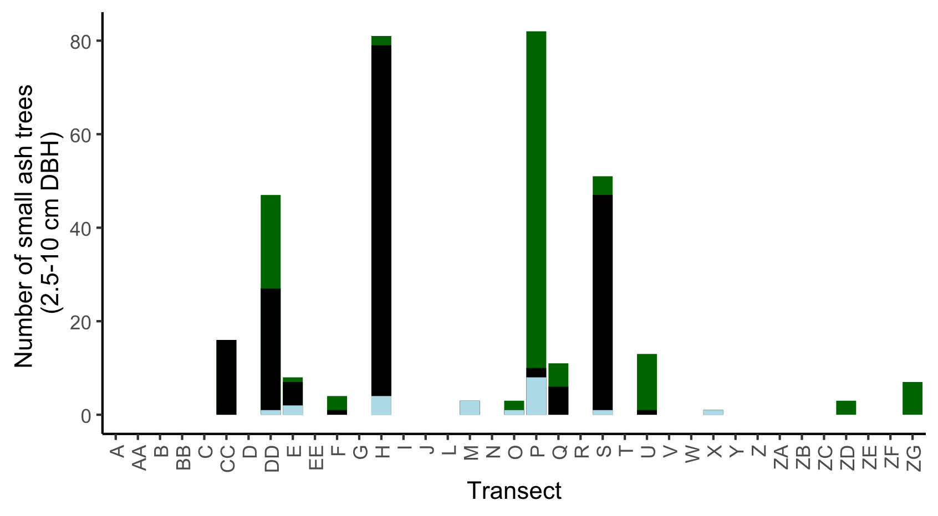

**Figure S1.** The total number of small ash trees (2.5 – 10 cm DBH) found in 37 transects in the Upper Huron River Watershed. Small ash of all canopy conditions are counted. Bars are shaded based on the proportion of each ash species that was found in a transect. Green represents green, white, and/or pumpkin ash; black represents black ash; light blue represents unknown ash species.

**Figure S2.** Yellow pan trap design using nested yellow bowls attached to a wooden stand and strapped to an ash tree.

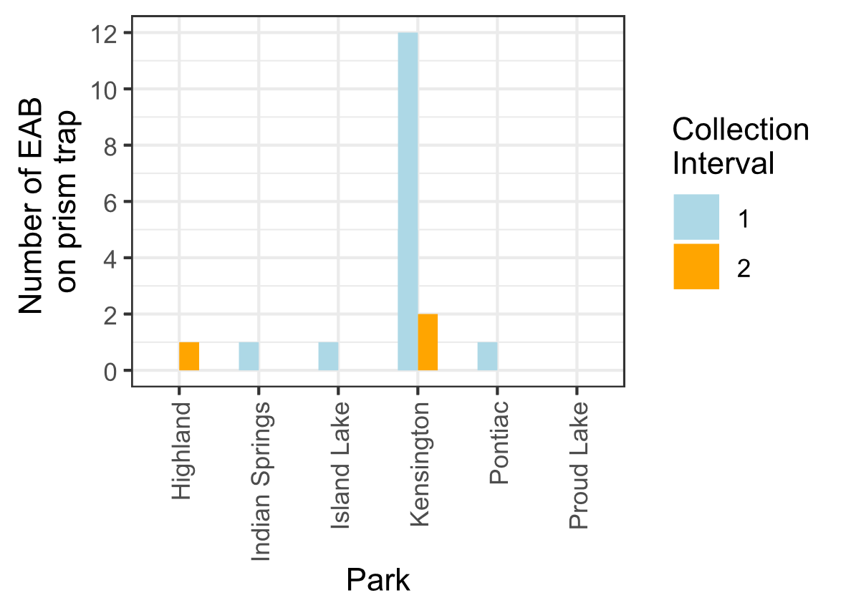

**Figure S3.** Captures of EAB adults from Prism traps in 2024. Collection interval 1 corresponds to June, while collection interval 2 corresponds to July.

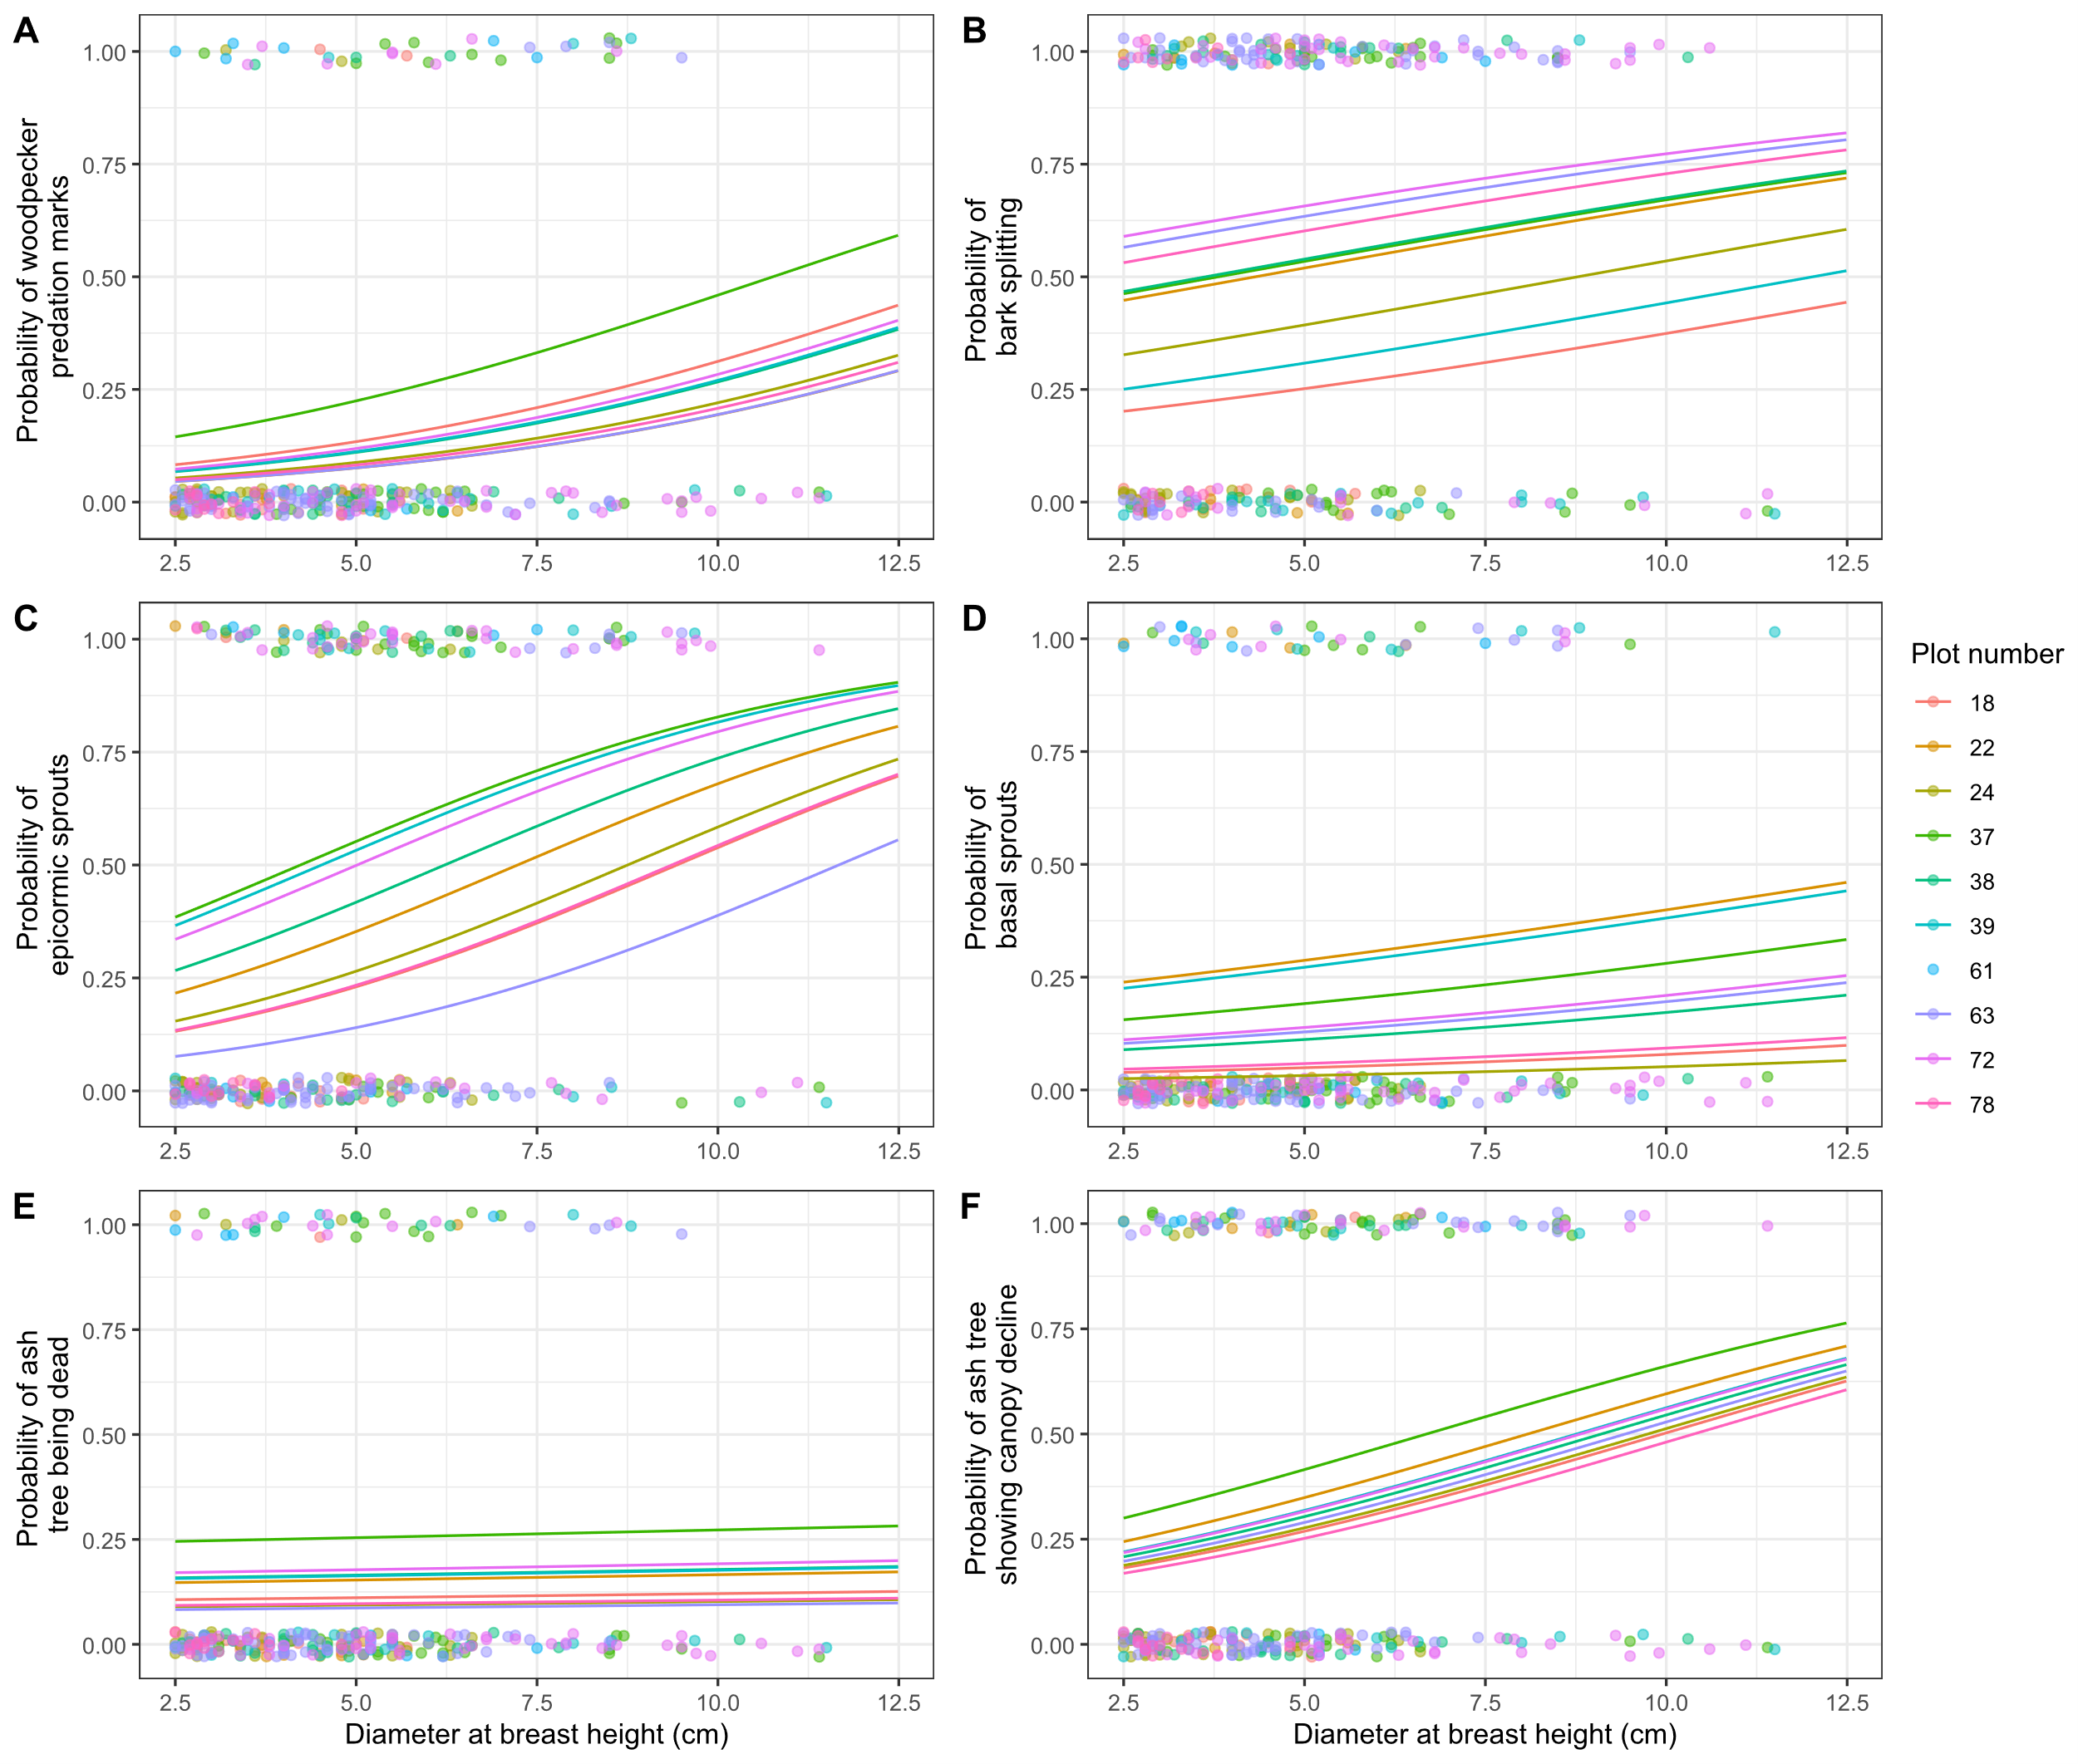

**Figure S4.** The presence or absence of symptoms of EAB plotted against tree diameter at breast height (DBH) for 283 trees in the 10 forest plots containing at least 10 trees. Colored points are individual trees, which are plotted as y=1 for presence or y=0 for absence (points were vertically jittered slightly). Points are colored based on the plot they belong to. Colored lines show the models for each estimated random intercept corresponding to each plot.

**References:**

Abell, K. J., J. J. Duan, L. Bauer, J. P. Lelito, and R. G. Van Driesche. 2012. The effect of bark thickness on host partitioning between Tetrastichus planipennisi (Hymen: Eulophidae) and Atanycolus spp. (Hymen: Braconidae), two parasitoids of emerald ash borer (Coleop: Buprestidae). Biological Control 63:320–325.

Abella, S. R., C. E. Hausman, J. F. Jaeger, K. S. Menard, T. A. Schetter, and O. J. Rocha. 2019. Fourteen years of swamp forest change from the onset, during, and after invasion of emerald ash borer. Biological Invasions 21:3685–3696.

Abella, S. R., K. S. Menard, T. A. Schetter, and C. E. Hausman. 2024. Species and landscape variation in tree regeneration and 17 years of change in forested wetlands invaded by emerald ash borer. Forest Ecology and Management 557:121750.

Aker, S. A., R. B. De Andrade, J. J. Duan, and D. S. Gruner. 2022. Rapid Spread of an Introduced Parasitoid for Biological Control of Emerald Ash Borer (Coleoptera: Buprestidae) in Maryland. Journal of Economic Entomology 115:381–386.

Aubin, I., F. Cardou, K. Ryall, D. Kreutzweiser, and T. Scarr. 2015. Ash regeneration capacity after emerald ash borer (EAB) outbreaks: Some early results. The Forestry Chronicle 91:291–298.

Barnes, B. V. 1976. Succession in deciduous swamp communities of southeastern Michigan formerly dominated by American elm. Canadian Journal of Botany 54:19–24.

Bates, D., M. Mächler, B. Bolker, and S. Walker. 2015. Fitting Linear Mixed-Effects Models Using **lme4**. Journal of Statistical Software 67.

Burns, R., and B. Honkala. 1990. Silvics of North America: Volume 2, Hardwoods.

Cipollini, D., and D. L. Peterson. 2018. The potential for host switching via ecological fitting in the emerald ash borer-host plant system. Oecologia 187:507–519.

Costilow, K. C., K. S. Knight, and C. E. Flower. 2017. Disturbance severity and canopy position control the radial growth response of maple trees (Acer spp.) in forests of northwest Ohio impacted by emerald ash borer (Agrilus planipennis). Annals of Forest Science 74:10.

Davis, J. C., J. P. Shannon, N. W. Bolton, R. K. Kolka, and T. G. Pypker. 2017. Vegetation responses to simulated emerald ash borer infestation in *Fraxinus nigra* dominated wetlands of Upper Michigan, USA. Canadian Journal of Forest Research 47:319–330.

Duan, J. J., L. S. Bauer, K. J. Abell, M. D. Ulyshen, and R. G. Van Driesche. 2015. Population dynamics of an invasive forest insect and associated natural enemies in the aftermath of invasion: implications for biological control. Journal of Applied Ecology 52:1246–1254.

Duan, J. J., L. S. Bauer, and R. G. Van Driesche. 2017. Emerald ash borer biocontrol in ash saplings: The potential for early stage recovery of North American ash trees. Forest Ecology and Management 394:64–72.

Duan, J. J., J. R. Gould, N. F. Quinn, T. R. Petrice, B. H. Slager, T. M. Poland, L. S. Bauer, C. E. Rutledge, J. S. Elkinton, and R. G. Van Driesche. 2023. Protection of North American ash against emerald ash borer with biological control: ecological premises and progress toward success. BioControl 68:87–100.

Engelken, P. J., M. E. Benbow, and D. G. McCullough. 2020. Legacy effects of emerald ash borer on riparian forest vegetation and structure. Forest Ecology and Management 457:117684.

Fox, J., and S. Weisberg. 2019. An {R} Companion to Applied Regression. Sage, Thousand Oaks {CA}.

Gandhi, K. J. K., and D. A. Herms. 2010. Direct and indirect effects of alien insect herbivores on ecological processes and interactions in forests of eastern North America. Biological Invasions 12:389–405.

Golet, F. C., J. A. Allen, U. S. Fish, and W. Service. 1993. Ecology of Red Maple Swamps in the Glaciated Northeast: A Community Profile. U.S. Department of the Interior, Fish and Wildlife Service.

Goulet, H., and J. T. Huber. 1993. Hymenoptera of the world: an identification guide to families. Agriculture Canada, Ottawa.

Hartig, F. 2024. DHARMa: Residual Diagnostics for Hierarchical (Multi-Level / Mixed) Regression Models. R.

Hoven, B. M., K. S. Knight, V. E. Peters, and D. L. Gorchov. 2020. Release and suppression: forest layer responses to emerald ash borer (Agrilus planipennis)-caused ash death. Annals of Forest Science 77:10.

Johnson, T. D., J. P. Lelito, and K. F. Raffa. 2014. Responses of two parasitoids, the exotic Spathius agrili Yang and the native Spathius floridanus Ashmead, to volatile cues associated with the emerald ash borer, Agrilus planipennis Fairmaire. Biological Control 79:110–117.

Kashian, D. M. 2016. Sprouting and seed production may promote persistence of green ash in the presence of the emerald ash borer. Ecosphere 7:e01332.

Klooster, W., K. Gandhi, L. Long, K. Perry, K. Rice, and D. Herms. 2018. Ecological Impacts of Emerald Ash Borer in Forests at the Epicenter of the Invasion in North America. Forests 9:250.

Klooster, W. S., D. A. Herms, K. S. Knight, C. P. Herms, D. G. McCullough, A. Smith, K. J. K. Gandhi, and J. Cardina. 2013. Ash (Fraxinus spp.) mortality, regeneration, and seed bank dynamics in mixed hardwood forests following invasion by emerald ash borer (Agrilus planipennis). Biological Invasions 16:859–873.

Knight, K. S., B. P. Flash, R. H. Kappler, J. A. Throckmorton, B. Grafton, and C. E. Flower. 2014. Monitoring Ash (Fraxinus spp.) Decline and Emerald Ash Borer (Agrilus planipennis) Symptoms in Infested Areas. General Technical Report, U.S. Department of Agriculture, Forest Service, Northern Research Station.

Koch, J. L., D. W. Carey, M. E. Mason, T. M. Poland, and K. S. Knight. 2015. Intraspecific variation in Fraxinus pennsylvanica responses to emerald ash borer (Agrilus planipennis). New Forests 46:995–1011.

Kolka, R., A. D’Amato, J. Wagenbrenner, R. Slesak, T. Pypker, M. Youngquist, A. Grinde, and B. Palik. 2018. Review of Ecosystem Level Impacts of Emerald Ash Borer on Black Ash Wetlands: What Does the Future Hold? Forests 9:179.

Kost, M. A., and R. P. O’Connor. 2003. Natural Features Inventory and Management Recommendations for Kensington and Oakwoods Metroparks. Michigan Natural Features Inventory, Huron-Clinton Metropolitan Authority.

Kreuzwieser, J., and H. Rennenberg. 2014. Molecular and physiological responses of trees to waterlogging stress. Plant, Cell & Environment 37:2245–2259.

Lenth, R. V. 2024. emmeans: Estimated Marginal Means, aka Least-Squares Means. R.

Lovett, G. M., C. D. Canham, M. A. Arthur, K. C. Weathers, and R. D. Fitzhugh. 2006. Forest Ecosystem Responses to Exotic Pests and Pathogens in Eastern North America. BioScience 56:395.

McCormick, J. F., and R. B. Platt. 1980. Recovery of an Appalachian Forest Following the Chestnut Blight or Catherine Keever-You Were Right! American Midland Naturalist 104:264.

McCullough, D. G. 2019. Challenges, tactics and integrated management of emerald ash borer in North America. Forestry: An International Journal of Forest Research 93:197–211.

Mech, A. M., K. A. Thomas, T. D. Marsico, D. A. Herms, C. R. Allen, M. P. Ayres, K. J. K. Gandhi, J. Gurevitch, N. P. Havill, R. A. Hufbauer, A. M. Liebhold, K. F. Raffa, A. N. Schulz, D. R. Uden, and P. C. Tobin. 2019. Evolutionary history predicts high‐impact invasions by herbivorous insects. Ecology and Evolution 9:12216–12230.

Megonigal, J. P., W. H. Conner, S. Kroeger, and R. R. Sharitz. 1997. Aboveground Production in Southeastern Floodplain Forests: A Test of the Subsidy-Stress Hypothesis. Ecology 78:370–384.

Morris, T. D., J. R. Gould, J. Drake, and M. K. Fierke. 2023. Status of ash forests and regeneration a decade after first detection of emerald ash borer infestation in New York state. Forest Ecology and Management 549:121464.

Murphy, T. C., R. G. Van Driesche, J. R. Gould, and J. S. Elkinton. 2017. Can Spathius galinae attack emerald ash borer larvae feeding in large ash trees? Biological Control 114:8–13.

Niinemets, Ü., and F. Valladares. 2006. Tolerance to Shade, Drought, and Waterlogging of Temperate Northern Hemisphere Trees and Shrubs. Ecological Monographs 76:521–547.

Online Phenology and Degree-day Models. 2022. . https://uspest.org/dd/model_app.

Parsons, G. 2008. Emerald Ash Borer: A guide to identification and comparison to similar species. Michigan State University Department of Entomology.

Perry, K., and D. Herms. 2019. Dynamic Responses of Ground-Dwelling Invertebrate Communities to Disturbance in Forest Ecosystems. Insects 10:61.

Petrice, T. R., L. S. Bauer, D. L. Miller, J. S. Stanovick, T. M. Poland, and F. W. Ravlin. 2021. Monitoring field establishment of the emerald ash borer biocontrol agent Oobius agrili Zhang and Huang (Hymenoptera: Encyrtidae): Sampling methods, sample size, and phenology. Biological Control 156:104535.

Petrice, T. R., T. M. Poland, L. S. Bauer, J. S. Strazanac, J. J. Duan, J. M. Schmude, and F. W. Ravlin. 2025. North American hymenopteran parasitoids of emerald ash borer larvae: seasonal abundance and interaction with introduced Asian parasitoids. The Canadian Entomologist 157:e7.

Quinn, N. F., J. J. Duan, and J. Elkinton. 2022a. Monitoring the impact of introduced emerald ash borer parasitoids: factors affecting Oobius agrili dispersal and parasitization of sentinel host eggs. BioControl 67:387–394.

Quinn, N. F., J. S. Gould, C. E. Rutledge, A. Fassler, J. S. Elkinton, and J. J. Duan. 2022b. Spread and phenology of Spathius galinae and Tetrastichus planipennisi, recently introduced for biocontrol of emerald ash borer (Coleoptera: Buprestidae) in the northeastern United States. Biological Control 165:104794.

Quinn, N. F., T. R. Petrice, J. M. Schmude, T. M. Poland, L. S. Bauer, C. E. Rutlege, R. G. Van Driesche, J. S. Elkinton, and J. J. Duan. 2023. Postrelease assessment of *Oobius agrili* (Hymenoptera: Encyrtidae) establishment and persistence in Michigan and the Northeastern United States. Journal of Economic Entomology 116:1165–1170.

R Core Team. 2024. R: A Language and Environment for Statistical Computing. R Foundation for Statistical Computing, Vienna, Austria.

Roy, H. E., L.-J. Lawson Handley, K. Schönrogge, R. L. Poland, and B. V. Purse. 2011. Can the enemy release hypothesis explain the success of invasive alien predators and parasitoids? BioControl 56:451–468.

Royo, A. A., and K. S. Knight. 2012. White ash (Fraxinus americana) decline and mortality: The role of site nutrition and stress history. Forest Ecology and Management 286:8–15.

Rutledge, C. E., R. G. Van Driesche, and J. J. Duan. 2021. Comparative efficacy of three techniques for monitoring the establishment and spread of larval parasitoids recently introduced for biological control of emerald ash borer, Agrilus planipennis (Coleoptera: Buprestidae). Biological Control 161:104704.

Schauff, M. E., and E. . Grissel. 1990. Key From: A handbook of the families of Nearctic Chalcidoidea (Hymenoptera). Entomological Society of Washington (Washington, D.C.) Handbook 1:1-85.

Shumway, D. L., K. C. Steiner, and M. D. Abrams. 1991. Effects of drought stress on hydraulic architecture of seedlings from five populations of green ash. Canadian Journal of Botany 69:2158–2164.

Siegert, N. W., P. J. Engelken, and D. G. McCullough. 2021. Changes in demography and carrying capacity of green ash and black ash ten years after emerald ash borer invasion of two ash-dominant forests. Forest Ecology and Management 494:119335.

Slesak, R. A., C. F. Lenhart, K. N. Brooks, A. W. D’Amato, and B. J. Palik. 2014. Water table response to harvesting and simulated emerald ash borer mortality in black ash wetlands in Minnesota, USA. Canadian Journal of Forest Research 44:961–968.

Smith, A. 2006. Effects of Community Structure on Forest susceptibility and Response to the Emerald Ash Borer Invasion of the Huron River Watershed in Southeast Michigan. Master’s Thesis, The Ohio State University.

Smith, A., D. A. Herms, R. P. Long, and K. J. K. Gandhi. 2015. Community composition and structure had no effect on forest susceptibility to invasion by the emerald ash borer (Coleoptera: Buprestidae). The Canadian Entomologist 147:318–328.

Tang, Z. C., and T. T. Kozlowski. 1984. Ethylene production and morphological adaptation of woody plants to flooding. Canadian Journal of Botany 62:1659–1664.

Telander, A. C., R. A. Slesak, A. W. D’Amato, B. J. Palik, K. N. Brooks, and C. F. Lenhart. 2015. Sap flow of black ash in wetland forests of northern Minnesota, USA: Hydrologic implications of tree mortality due to emerald ash borer. Agricultural and Forest Meteorology 206:4–11.

Timms, L. L., S. M. Smith, and P. De Groot. 2006. Patterns in the within‐tree distribution of the emerald ash borer *Agrilus planipennis* (Fairmaire) in young, green‐ash plantations of south‐western Ontario, Canada. Agricultural and Forest Entomology 8:313–321.

Tluczek, A. R., D. G. Mccullough, and T. M. Poland. 2011. Influence of Host Stress on Emerald Ash Borer (Coleoptera: Buprestidae) Adult Density, Development, and Distribution in <I>Fraxinus pennsylvanica</I> Trees. Environmental Entomology 40:357–366.

USDA–APHIS/ARS/FS. 2021. Emerald Ash Borer Biological Control Release and Recovery Guidelines. USDA–APHIS–ARS–FS, Riverdale, Maryland.

Van Driesche, R., and R. Reardon. 2016. The Use of Classical Biological Control to Preserve Forests in North America. USDA Forest Service, Morgantown, WV.

Venables, W. N., B. D. Ripley, and W. N. Venables. 2002. Modern applied statistics with S. 4th ed. Springer, New York.

Villari, C., D. A. Herms, J. G. A. Whitehill, D. Cipollini, and P. Bonello. 2016. Progress and gaps in understanding mechanisms of ash tree resistance to emerald ash borer, a model for wood‐boring insects that kill angiosperms. New Phytologist 209:63–79.

Wagner, D. L., and K. J. Todd. 2015. Chapter 2: Ecological Impacts of Emerald Ash Borer. Page Biology and Control of Emerald Ash Borer. USDA Forest Service.

Ward, S. F., A. M. Liebhold, R. S. Morin, and S. Fei. 2021. Population dynamics of ash across the eastern USA following invasion by emerald ash borer. Forest Ecology and Management 479:1–8.

Wilson, C. J., T. R. Petrice, T. M. Poland, and D. G. McCullough. 2024. Tree species richness and ash density have variable effects on emerald ash borer biological control by woodpeckers and parasitoid wasps in post-invasion white ash stands. Environmental Entomology 53:544–560.

Zhang, Y.-Z., D.-W. Huang, T.-H. Zho, H.-P. Liu, and L. S. Bauer. 2005. Two new species of egg parasitoids (hymenoptera: Encyrtidae) of wood-boring beetle pests from China. Phytoparasitica 33:253–260.